ACKNOWLEDGEMENT
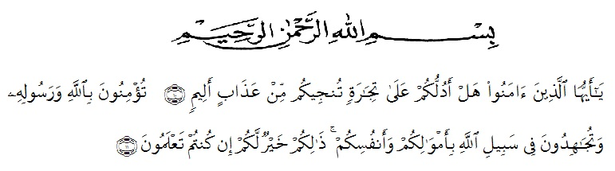
Bismillahirrahmanirrahim

Artinya : “Hai orang-orang yang beriman, sukakah kamu aku tunjukkan suatu perniagaan yang dapat menyelamatkanmu dari azab yang pedih?(10). (Yaitu) kamu beriman kepada Allah dan RasulNya dan berjihad di jalan Allah dengan harta dan jiwamu. Itulah yang lebih baik bagimu, jika kamu mengetahui. (11) (As-Shaff ayat 10-11)”.

All praise is to Allah, the Almighty, the Merciful, for the blessing given tome so that the writer could finish this thesis. She would also like to thank all of those who have given support, guidance, and assistance without which I would have neverfinished this study. To His messenger, peace and blessing be upon Prophet Muhammad SAW, his family, his relatives, and all his followers.
The written of this skripsi entitled “Improving Students’ Speaking Skill by Using Recitation Method in Idiomatic Expression at Eight Grade of SMP Swasta Pembangun Medan”. This skripsi is written to fulfill one requirement to obtain the Sarjana degree at Department of English Education of University of Muslim Nusantara Al Washliyah Medan.

Finishing of Writing this skripsi is actually a miracle for the writer since it wasfirstly regarded as a task would be very hard to do. However, it has now beendenied since this skripsi has finally been written. Then, the writer would like to thankAllah SWT for The Blessing given to the writer so that the writing of this skripsi hasbeen finished without any meaningful problem. Additionally, the writer is gratefulto the following for their supports and helps.
The writer also would like to give the special thanks for :
- H. Hardi Mulyono, S.E, M.AP as Rector of University of Muslim Nusantara Al Washliyah
- Drs. Mhd, Ayyub Lubis, M.Pd Ph.D as dean of faculty of English Department of University of Muslim Nusantara Al Washliyah
- Drs. H. M.Khalid, M.Hum., as head of English Department of University of Muslim Nusantara Al Washliyah and as the first advisor who has given the writer advice, motivation, kindness, and taught the writer dicipline.
- Dahlia Sirait, S.pd., M.Hum., as the second consultant who never stopped helping her in guiding and correction the pettern of this study.
- The lecturer of English Department of University of Muslim Nusantara Al Washliyah for their advice,motivation,and useful knowledge.
- All librarians of University of Muslim Nusantara Al-Washliyah for their willingness to serve the writer all the time.
- All staf of faculty of FKIP University of muslim Nusantara Al Washliyah for all fasilities that have been given to the researcher during studied in the faculty.
- Muhammad Yusuf,B.A as the headmaster,and also all the teachers who allowed and also helped writer conducting this study of the second year at SMP Swasta Pembangun Medan for their participation in this research.
- A profound gratitude is directed to her beloved parents H. Aris Muda Dongoran, S.sos., and Hj. Siti Omin Dalimunthe, S.Pd., who always give the writer support, advice, motivation, help, goodness, care, and all of things that the writer need to finish this study.
- The writer’sall of beloved friends in English Department A at University of Muslim Nusantara Al Washliyah for cheerful days and togetherness, also to the writer’s comrade for their pray,motivation,and for being place to share. The writer hope this script will be useful to improve the education in general and English teaching in particular.
Finally, the writer would like to say thanks a lot for all of support which are given so that the script can be finished well.
Medan, Mei 2018
The Writer

Herlina Sari Dongoran
NPM: 141244105

