**ACKNOWLEDMENT**

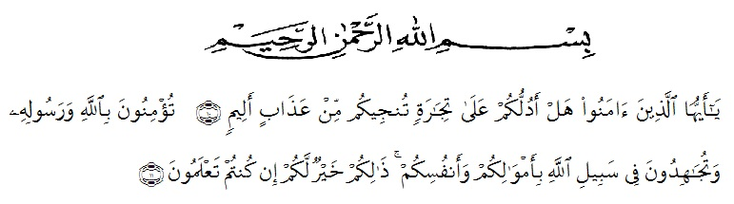

Artinya: “Hai orang-orang yang beriman, sukakah kamu Aku tunjukkan suatu perniagaan yang dapat menyelamatkan kamu dari azab yang pedih? (yaitu) kamu beriman kepada Allah dan Rasul-Nya dan berjihad di jalan-Nya dengan harta dan jiwamu, itulah yang lebih baik bagimu jika kamu mengetahuinya.”

(*QS. ash-Shaff: 10-12*).

Thanks to Allah SWT the Great, the Merciful and benefitcent so that this research can be accepted by any part.

In conducting this research, the writer received suggestion, assistance, criticism, and guidance from any person. Therefore, the writer would like to express her great appreciation to them, especially:

1. **H. Hardi Mulyono, S.E., M.AP,** as the Rector of UMN Al-Washliyah Medan, for facilities given during the academic years.
2. **Drs. M. Ayyub Lubis, M.Pd., Ph.D,** as the Dean of FKIP UMN Al-Washliyah Medan and his staffs for facilities given to her.
3. **Drs. M. Khalid M. Hum,** as the Head of English Department at UMN Al-Washliyah Medan.
4. **Prof. Dr. H. Ahmad Laut Hasibuan, M.Pd,** asthe first consultant, who has given her a lot of valuable suggestions, comments and criticsm for completing this research.
5. **Rini Fadhillah Putri, S.Pd. M. Hum,** as the second consultant, who has never stopped helping her in guiding and correcting the pattern of this research.
6. All lectures, at the English Development who have dedicated their valuable knowledge for during the academic years at UMN Al-Washliyah Medan.
7. **Asnawi S.Pd. M.Hum,** asthe consultan academic, who has given her a lot of inspiration and helping the academic at UMN Al-Washliyah Medan.
8. **Arfanda A. Siregar, M.Si.** The Headmaster of SMP IT ALI BIN ABI THALIB Tanjung Morawa for facilities given to her in conducting this reasearch.
9. The deepest and special lover to her parents **ABDUL HAKIM SARAGIH** and **NUR ARIFAH.** Also her beloved family my young sister **NUR ADINA SARAGIH** and young brother **MUHAMMAD ABDILLAH SARAGIH** who have given their spirit, love, moral support, and their praying during the writing and conducting this research.
10. Thank to **SRI RAMADANI** as a teacher and friend for me, thanks for given love, support and her praying during the writing and conducting this research.
11. Thanks to **VIII.A English Department** who have given time, support and spirit during the writing and conducting this research.
12. Her best friend **IPS2 of Nusantara Lubuk Pakam** who has given love, support and spirit from the first until last to finish this thesis.
13. Her beloved teacher **CITRA, IDA** and **all of teacher (PPL 2008)** who has given love, support and their praying.
14. Her beloved teachers in SMP IT ALI BIN ABI THALIB, who have never give up supporting her in Clompleting this research.
15. Thanks to my beloved big family **Alm. DEMAN SARAGIH** and family who never give up to supporting the writer.
16. Thanks to my beloved big family **Alm. ZUBAIDI SALAM** and family who give love and never give up supporting to the writer.
17. Thanks to all of my teacher from in the Primary School, jonior high school and senior high school who have given sains, love and never give up to supporting the writer.

Finaly, the researcher realizes that this research is still far from being perfect. Therefore, the researcher does appreciate some comments, criticsm, and other constractive suggestion to lead this research better.

Medan, July 2018

The writer,

**HIKMA TUL ARAFAH SARAGIH**