IMPROVING STUDENTS’ SPEAKING SKILL THROUGH COMMUNICATIVE CONVERSATION OF GRADE 5 STUDENTS AT SDN 101878
TANJUNG MORAWA ACADEMIC YEARS 2018/2019

SKRIPSI

BY

FAZRIA TRI ALDILA
141244100

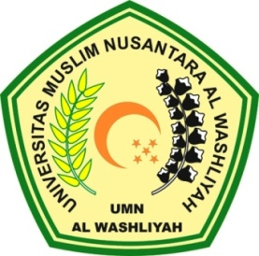

FAKULTAS KEGURUAN DAN ILMU PENDIDIKAN
UNIVERSITAS MUSLIM NUSANTARA ALWASHLIYAH
MEDAN
2018

FAKULTAS KEGURUAN DAN ILMU PENDIDIKAN
UNIVERSITAS MUSLIM NUSANTARA AL WASHLIYAH

TANDA PERSETUJUAN

NAMA : FAZRIA TRI ALDILA
NPM : 141244066
JURUSAN : Pendidikan Bahasa dan Seni
PROGRAM STUDI : Pendidikan Bahasa Inggris
JENJANG PENDIDIKAN : Strata Satu (S-1)
JUDUL : Improving Students’ Speaking Skill through Communicative Conversation of Grade 5 Students of SDN 101878 TanjungMorawa Academic Years 2018/2019

Pembimbing I Pembimbing II

Prof. Dr. H. Ahmad Laut Hasibuan, M.Pd Drs. Ely Ezir, M.S

DiujiPadaTanggal :
Judicium :

Ketua Sekretaris

H. Hardi Mulyono Surbakti, SE, M.AP Drs. Mhd. Ayyub Lubis, M.Pd, Ph.D
IMPROVING STUDENTS’ SPEAKING SKILL THROUGH COMMUNICATIVE CONVERSATION OF GRADE 5 STUDENTS AT SDN 101878
TANJUNG MORAWA ACADEMIC YEARS 2018/2019

This Skripsi is Submitted to Complete the Duties and Meet the Requirements to Achieve a Bachelor Degree in Education Majoring in Language Education and Arts Education Course of English Language Education

SKRIPSI

BY:

FAZRIA TRI ALDILA
NPM : 141244100

FAKULTAS KEGURUAN DAN ILMU PENDIDIKAN
UNIVERSITAS MUSLIM NUSANTARA ALWASHLIYAH
MEDAN
2018

