ACKNOWLEDGEMENT

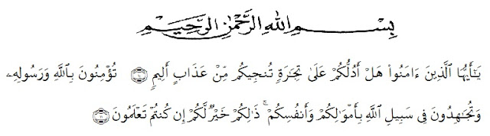
Artinya : “Hai orang-orang yang beriman, sukakah kamu aku tunjukkan suatu perniagaan yang dapat menyelamatkanmu dari azab yang pedih?(10). (Yaitu) kamu beriman kepada Allah dan RasulNya dan berjihad di jalan Allah dengan harta dan jiwamu. Itulah yang lebih baik bagimu, jika kamu mengetahui. (11) (As-Shaff ayat 10-11)”

First of all, the researcher wishes to express her great thank to Allah SWT, The Most Gracious and The Most Merciful. The writer also wants to present Sholawat and Salam to the prophet Muhammad SAW.
In completing this skripsi, the researcher got suggestion, critics, comments and supports from many persons. Therefore, the researcher would like to express her greatest thank to the following persons, especially to :
- H. Hardi Mulyono, SE, M.AP, as the Rector of Universitas Muslim Nusantara Al Washliyah.
- Drs. M. Ayyub Lubis, M.Pd, Ph.D, as the Dean of FKIP Universitas Muslim Nusantara Al Washliyah.
- Drs. H. M. Khalid, M.Hum, as the Chairman in English Section in English Department.
- Prof. Dr. H. Ahmad Laut Hasibuan, M.Pd, as the first consultant who has given her a lot of valuable suggestion, comments, and criticisms for completing this research.
- Drs. Ely Ezir M.S, as the second consultant who never stopped helping her in guiding and correcting the pattern of this research.
- The headmaster of SDN 101878 TG.MORAWA in giving the facilities to her in conducting this research.
- The librarian of Universitas Muslim Nusantara Al Washliyah for the needed books in writing this research.
- The lecturers of English Section in Language Departement of FKIP UMN Al Washliyah Medan for sharing their nice and valuable ideas to enrich the writer’s knowledge.
- The writer’s beloved parents, Mr. Erwinson and Ms. Tuti Hairani gave her important motivation, financially, suggestion, attention and always keep the prayer for her.
- The writer’s classmate in class A of English Department, for cheerful days and togetherness, also to her comrade for their pray, motivation, and for being place to share.
Hopefully, this skripsi gives many benefits for the reader and the writers.
Medan, 2018
The Writer

FAZRIA TRI ALDILA

