**ACKNOWLEDGEMENT**

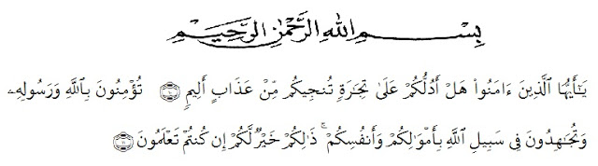

*Artinya* : “Hai orang-orang yang beriman, sukakah kamu aku tunjukkan suatu perniagaan yang dapat menyelamatkanmu dari azab yang pedih?(10). (Yaitu) kamu beriman kepada Allah dan RasulNya dan berjihad di jalan Allah dengan harta dan jiwamu. Itulah yang lebih baik bagimu, jika kamu mengetahui. (11) (As-Shaff ayat 10-11)”

First of all, the researcher wishes to express her great thank to Allah SWT, The Most Gracious and The Most Merciful. The writer also wants to present Sholawat and Salam to the prophet Muhammad SAW.

In completing this skripsi, the researcher got suggestion, critics, comments and supports from many people. Therefore, the researcher would like to express her greatest thank to the following people, especially to :

1. H. Hardi Mulyono, SE, M.AP, as the Rector of Universitas Muslim Nusantara Al Washliyah.
2. Drs. M. Ayyub Lubis, M.Pd, Ph.D, as the Dean of FKIP Universitas Muslim Nusantara Al Washliyah.
3. Drs. H. M. Khalid, M.Hum, as the Head of English Department.
4. Prof. Dr. Syahron Lubis, M.A, as the first consultant who has given her a lot of valuable suggestions, comments, and criticism in completing this research.
5. Rini Fadhillah Putri, S.Pd, M.Hum, as the second consultant who never stopped helping her in guiding and correcting the pattern of this research.
6. All staff of Faculty of FKIP Universitas Muslim Nusantara Al Washliyah for all facilities that have been given to the researcher during her studies in the faculty.
7. The headmaster of SMP NEGERI 1 PATUMBAK in giving the facilities to her in conducting this research.
8. The librarians of Universitas Muslim Nusantara Al Washliyah for the needed books in doing this research.
9. The lecturers of English in Language Departement of FKIP Universitas Muslim Nusantara Al Washliyah Medan for sharing their nice and valuable ideas to enrich the writer’s knowledge.
10. The writer’s beloved parents, Mr. Yusuf Sitorus and Ms. Hotbina Tampubolon. The writer’s beloved brothers and sister who always supported her, give her important motivation, financial, suggestion, support and always keep sending prayer for her.
11. The writer’s classmates of class A of English Department and especially her best friend Nurfadilla Sitorus, who always supports and motivate her in her studies.

Hopefully, this skripsi would give much benefit for the readers.

Medan, 2018

The Writer

**Mutiara Patimah Sitorus**

**141244034**