**ACKNOWLEDGEMENTS**

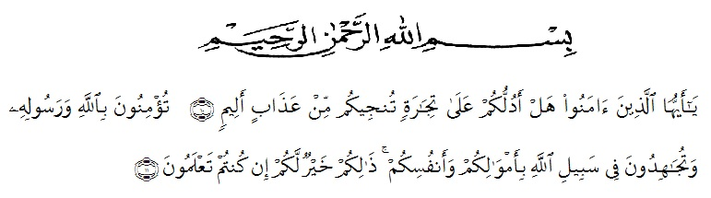

Artinya :

Hai orang-orang yang beriman, sukakah kamu aku tunjukkan suatu perniagaan yang dapat menyelamatkanmu dari azab yang pedih? (10). (yaitu) kamu beriman kepada Allah dan Rasul-Nya dan berjihad di jalan Allah dengan harta dan jiwamu. Itulah yang lebih baik bagimu, jika kamu mengetahui. (11) (As-Shaff ayat 10-11).

First of all, the researcher wishes to express her great thank to Allah SWT, The Most Gracious and The Most Merciful. The writer also wants to present Sholawat and Salam to the prophet Muhammad SAW.

In completing this skripsi, the researcher got suggestion, critics, comments and supports from many people. Therefore, the researcher would like to express her greatest thank to the following people, especially to :

1. H. HardiMulyono, SE. MAP, as the Rector ofUniversitasMuslim Nusantara Al Washliyah Medan.
2. Drs. M. AyyubLubis, M.Pd, Ph.D, as the Dean of FKIP UniversitasMuslim Nusantara Al Washliyah Medan.
3. Drs. H. M. Khalid, M.Hum, as the Head of English Department.
4. Dr.Hj.Risnawaty,M.Hum, as the First Consultant who has given her a lot of valuable suggestion, comments, and criticisms for completing this research.
5. RiniFadhillahPutri, S.Pd.,M.Hum as the Second Consultant who has never stopped helping her in guiding and correcting the pattern of this research.
6. All staffs of Faculty of FKIP Universitas Muslim Nusantara Al Washliyah Medan for all facilities that have been given to the researcher during studied in the faculty
7. All her beloved lecturers of English Section of Language Department FKIP UMN Al Washliyah Medan, thanks for their nice and valuable discussing to improve her knowledge.
8. The headmaster of SMP Swasta Rakyat Pancurbatu who gave a chance for the writer to conducting this research.
9. The librarians of FKIP UMN Al Washliyah Medan, UNIMED and Regional Library Medan, for the books needed in conducting this research.
10. The writer’s beloved parentsAchmadBuyung andMariani who have supported her, always given her love and care and prayer that have been given her born until forever.
11. The writer’s beloved sisters, RifkaFitriRahayu, RifkaYuniAnggraini, RifkaSuciHariyani, RifkaFridaMutiara and brotherTimbulSantoso who have given support her to finish this research.
12. The writer’s beloved best friends who have encouraged, given motivation, and helped her in completing the data to finish this research.
13. All of her beloved classmates in VIII A English Department of Universitas Muslim Nusantara Al Washliyah Medan.
14. And the last her beloved special friend Refanggawho has supported her, always given her love, care and prayer her to finish this research.

Finally the writer render thanks to various side which have given her mind contribution so that finally this research can be finished. Hopefully this research can reach the target expected and this skripsi can give many benefits for the readers and the writer.

Medan,Juli 2018

The Writer,

RifkaFebrinaWulandari