**ACKNOWLEDGEMENTS**

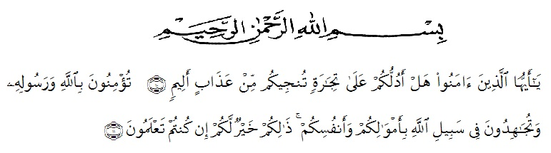

Artinya :

Hai orang-orang yang beriman, sukakahkamuakutunjukkansuatuperniagaan yang dapatmenyelamatkanmudariazab yang pedih? (10). (yaitu) kamuberimankepada Allah danRasul-Nya danberjihad di jalan Allah denganhartadanjiwamu. Itulah yang lebihbaikbagimu, jikakamumengetahui. (11) (As-Shaffayat 10-11).

Alhamdulillahi rabbil ‘alamin, the researcher expresses her highest gratitude to Allah subhanahu wa ta’ala for blessing, love, opportunity, health, and mercy to complete this thesis. Shalawat is also sent to Prophet Muhammad shallallahu ‘alaihi wa sallam who had delivered the truth to human beings in general and Muslim in particular.

            In arranging this thesis, a lot of people have provided motivation, advice, support, and even remark that had helped the researcher. In this valuable chance, researcher aims to express her gratitude and appreciation to all of them.

1. H. Hardi Mulyono, SE. MAP, as the Rector of Universitas Muslim Nusantara Al Washliyah Medan.
2. Drs. M. Ayyub Lubis, M.Pd, Ph.D, as the Dean of FKIP UniversitasMuslim Nusantara Al Washliyah Medan.
3. Drs. H. M. Khalid, M.Hum, as the Head of English Department.
4. Prof Dr. H. Ahmad Laut Hasibuan M.Pd, as the First Consultant who has given his a lot of valuable suggestion, comments, and criticisms for completing this research.
5. Junaidi, S.S., S.Pd., M.Si,the Second Consultant who has never stopped helping his in guiding and correcting the pattern of this research.
6. All staffs of Faculty of FKIP Universitas Muslim Nusantara Al Washliyah Medan for all facilities that have been given to the researcher during studied in the faculty.
7. All beloved lecturers of English Section of Language Department FKIP UMN Al Washliyah Medan, thanks for their nice and valuable discussing to improve knowledge.
8. The headmaster of Yayasan Perguruan SMK Dharma Karya Beringin who gave a chance for the writer to conducting this research.
9. The librarians of FKIP UMN Al Washliyah Medan, UNIMED and Regional Library Medan, for the books needed in conducting this research.
10. The writer’s beloved parents who have supported her and always given her love and care.
11. The writer’s beloved families who have given support her to finish this research.
12. The writer’s beloved best friends pakam groups’ who have encouraged, given motivation, and helped her in completing the data to finish this research.
13. All of her beloved classmates in VIII A English Department of Universitas Muslim Nusantara Al Washliyah Medan.

Finally, the writer surrenders everything to Allah SWT and the writer hope this skripsi can gives many benefits for the reader and the writers.

Medan, Juli 2018

The Writer,

Nurmalia