APPENDIX B
The Answer of Test by Using Picture Media
Name :
Class :
“ How to make burger “
Write the ingredients used in making burger
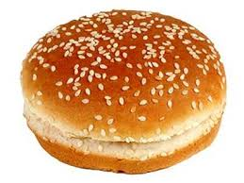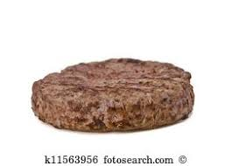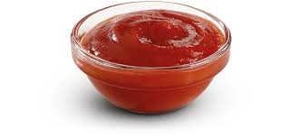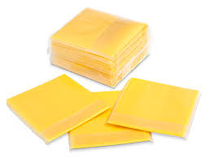
Bread Beef Slice of Tomatoes Tomato Sauce Slice Cheese
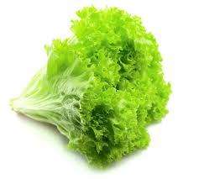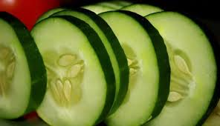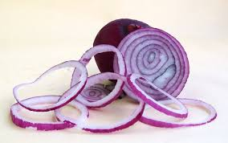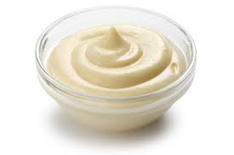
Salad Slice of Cucumber Red Union Butter Mayonnaise
Write the steps in making burger

Steps :
- First, slice the bread into two parts to and buttom.
- Second, butter the surface of the bread and the beef, put its surface on the hot pan for about 30 seconds.
- Third, take the bread put the tomato sauce, slice cheese, red union, beef and slice cheese.
- After that, add slice tomato, slice cucumber, tomato sauce, salad, mayonnaise.
- Then, Put Cover the top with a piece of the top burger patties.
- Finally, the burgers are ready to serve.

