**Lampiran 1.** Hasil Identifikasi Tumbuhan

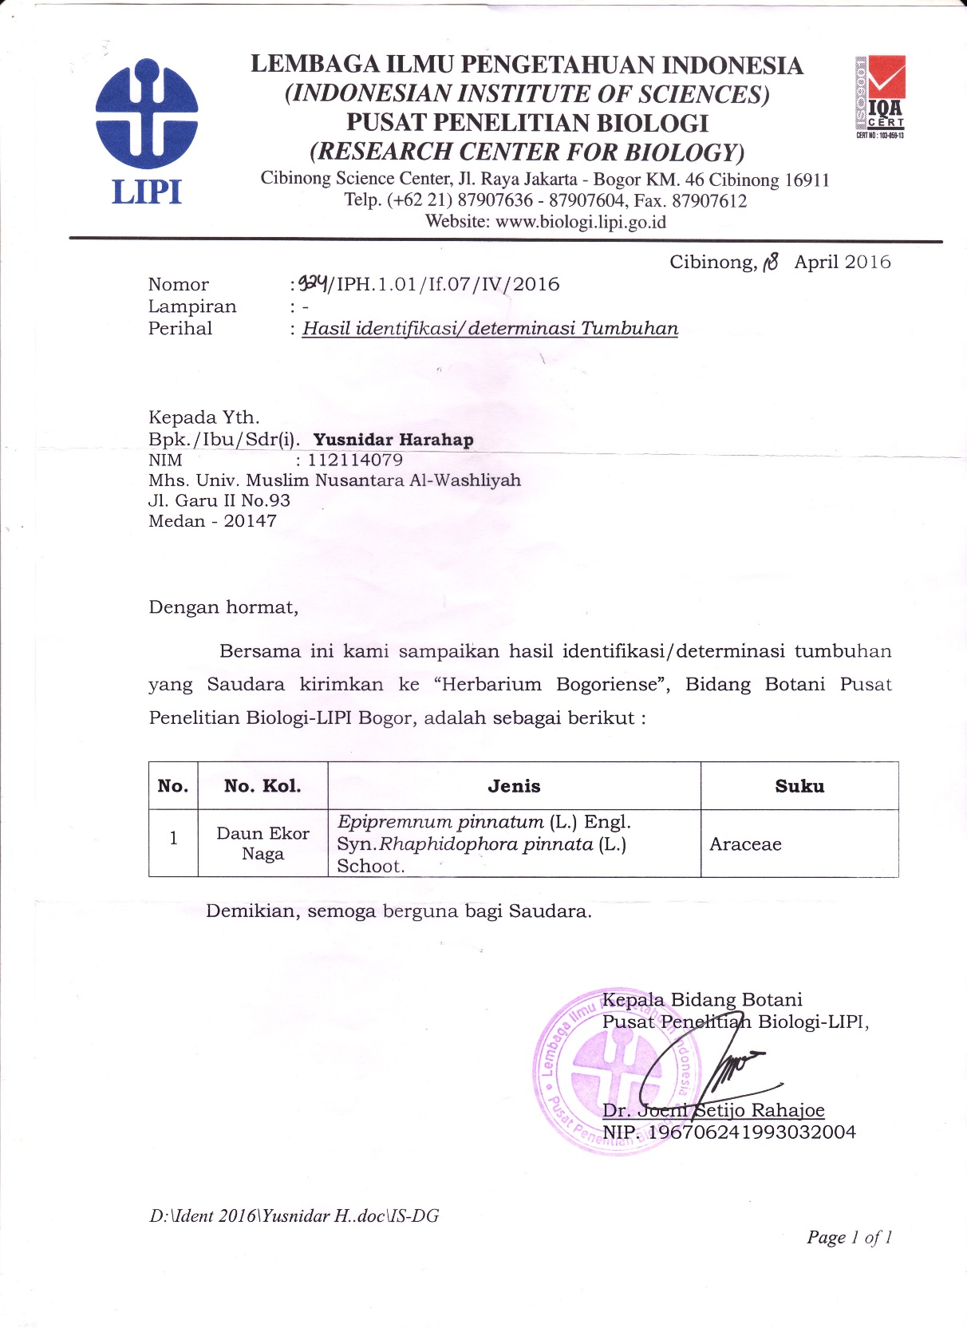

**Lampiran 2.** Hasil Identifikasi Hewan Percobaan

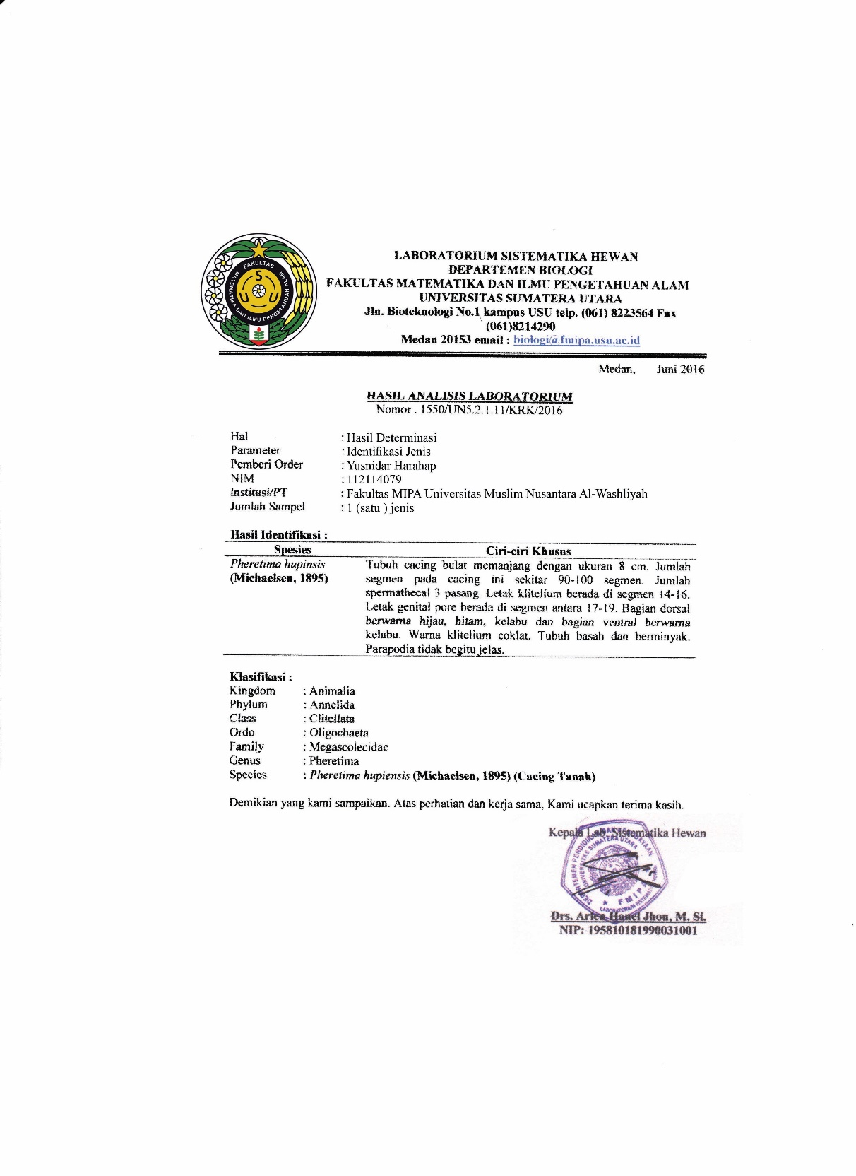

**Lampiran 3.** Surat Sertifikat Bahan Baku Obat



**Lampiran 4.** Tanaman Daun Ekor Naga (Rahphidophorapinnata (L.) Schoot) Dan Gambar Simplisia Segar Daun Ekor Naga (Rhaphidophora pinnata (L.) Schoot).

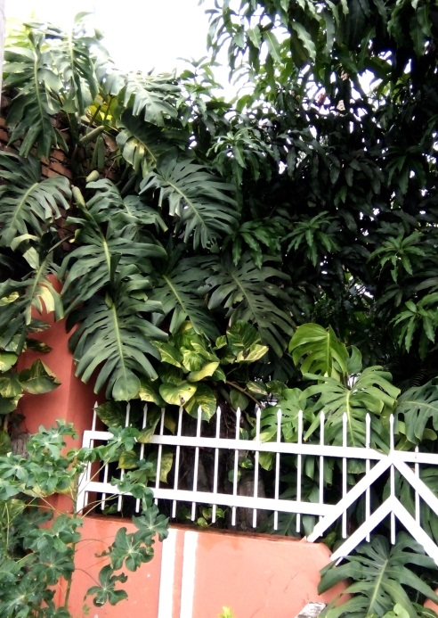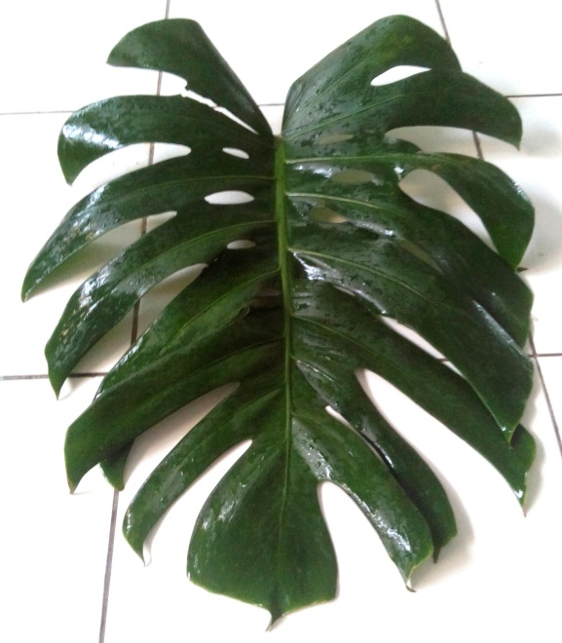

**Daun Ekor Naga**

(*Raphidophora pinnata* (L.)Schoot*)*

**Tanaman Daun Ekor Naga**

(*Raphidophora pinnata* (L.) Schoot*)*

**Lampiran 5.** Simplisia Kering Daun Ekor Naga Dan Serbuk Simplisia Daun Ekor Naga.

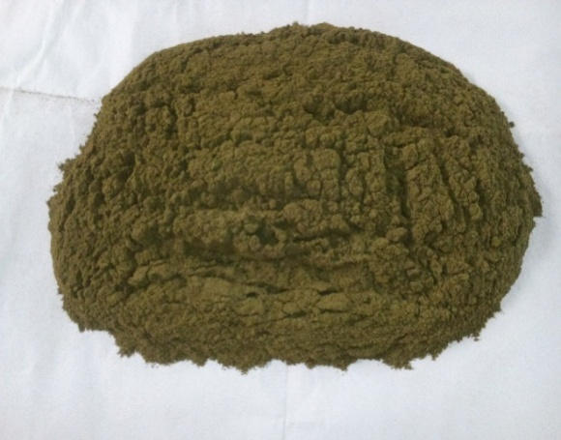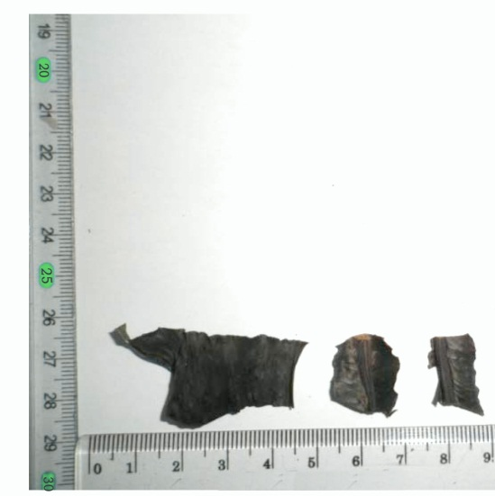

**Serbuk Simplisia Daun Ekor Naga**

*(Raphidophora pinnata* (L.) Schoot)

**Simplisia Kering Daun Ekor Naga**

*(Raphidophora pinnata* (L.) Schoot)

**Lampiran 6. Cacing *Pheretima hupiensis***



**Cacing *Pheretima hupiensis***

**Lampiran 7. Ekstrak Daun Ekor Naga**

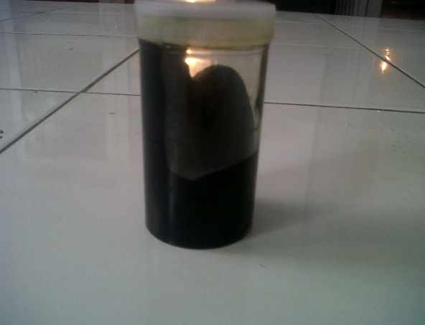

**Ekstrak Daun Ekor Naga**

(*Raphidophora pinnata* (L.) Schoot)

**Lampiran 8. Mikroskopik Daun Ekor Naga (*Rhaphidophora pinnata* (L.) Schoot)**

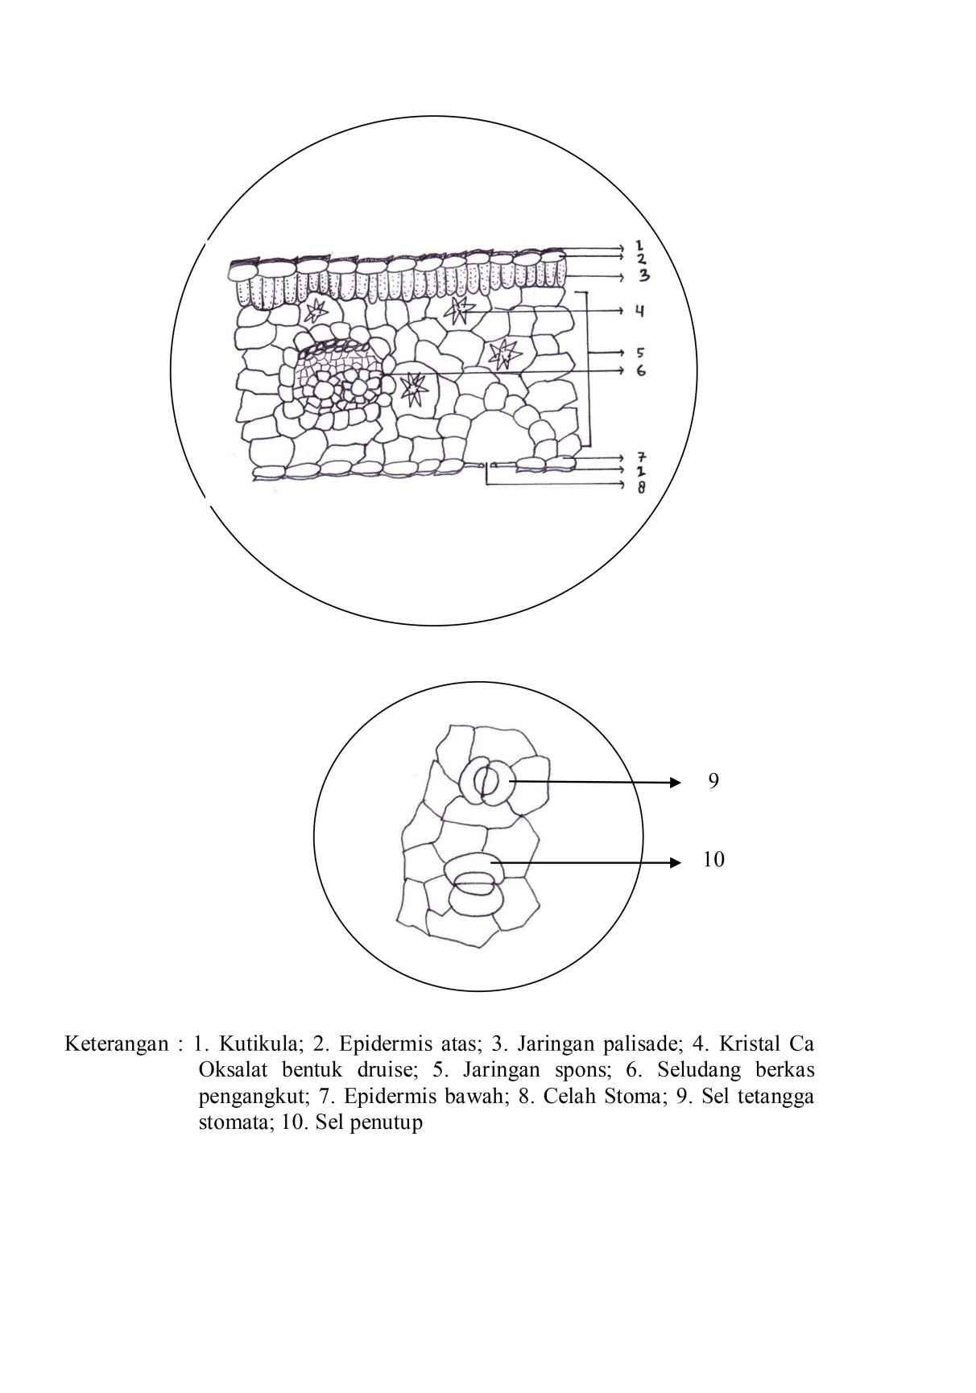

**Lampiran 9.** Uji Aktivitas Antelmintik

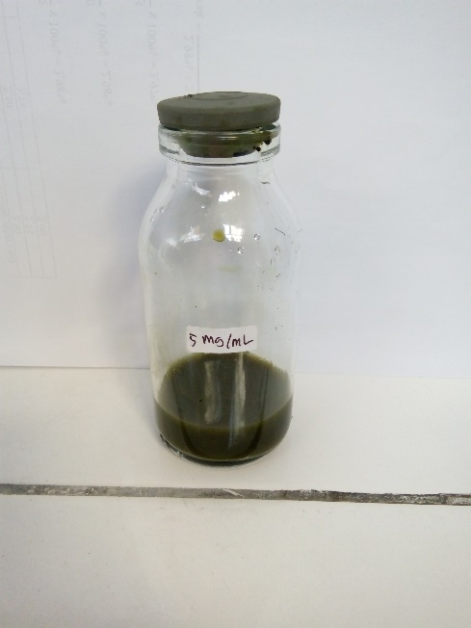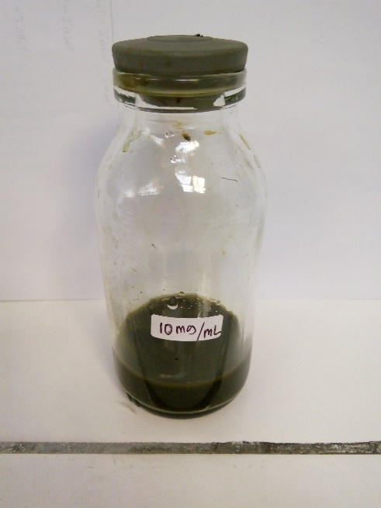Suspensi Ekstrak Etil asetat Daun Ekor Naga

EEADEN 5 mg/ml EEADEN 10 mg/ml

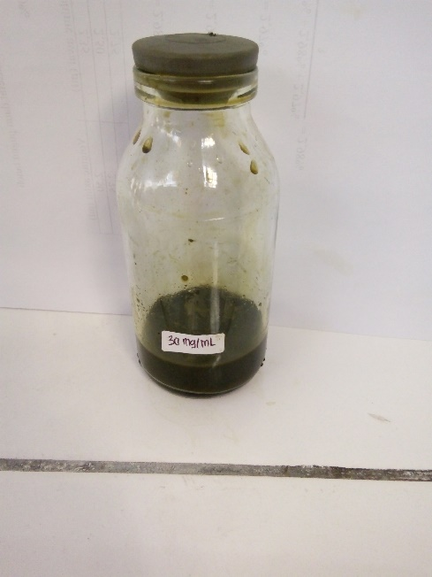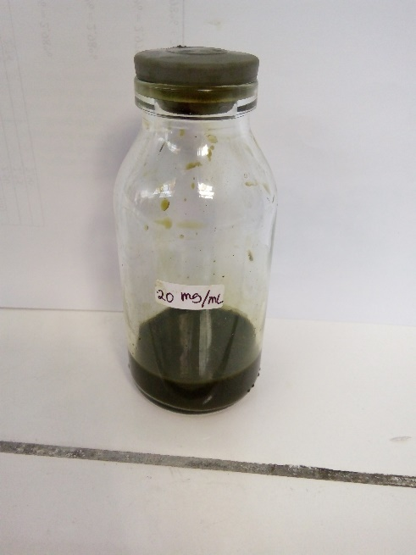

EEADEN 20 mg/ml EEADEN 30 mg/ml

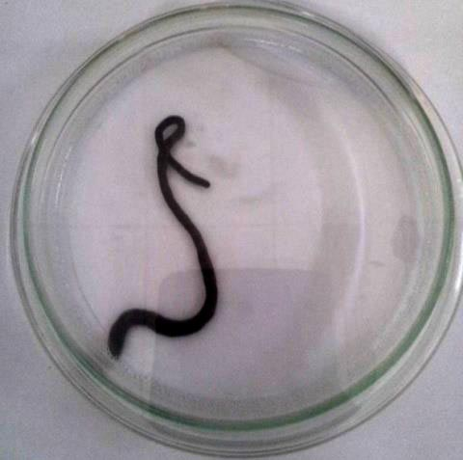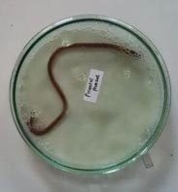

Kontrol Positif Suspensi Pirantel Pamoat

Kontrol pelarutdengan Tween 80 1%

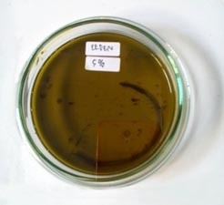

Pemberian suspensi EEADEN 5 mg/ml Perubahan Morfologi Cacing

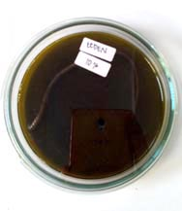

Pemberian suspensi EEADEN 10 mg/ml Perubahan Morfologi Cacing

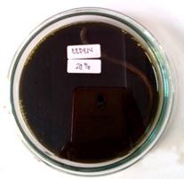

Pemberian suspensi EEADEN 20 mg/ml Perubahan Morfologi Cacing

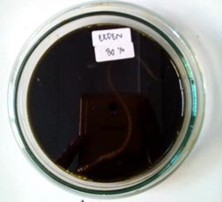

Pemberian suspensi EEADEN 30 mg/ml Perubahan Morfologi Cacing

**Lampiran10.** Hasil Perhitungan Rendemen Simplisia

|  |  |
| --- | --- |
| Berat Basah (gram) | Berat Simplisia (gram) |
| 1850 | 450 |

$$\% Rendemen Simplisia=\frac{Berat simplisia}{Berat basah}× 100\%$$

$$=\frac{450}{1850}×100 \% =24,32 \%$$

**Lampiran11.** Hasil Perhitungan Kadar Air Simplisia

|  |  |  |
| --- | --- | --- |
| BeratSampel (gram) | Volume Awal (ml) | Volume Akhir (ml) |
| 5,030 | 1,90 | 2,15 |
| 5,010 | 2,00 | 2,20 |
| 5,025 | 2,23 | 2,30 |

$$\% Kadar air=\frac{volume akhir-volume awal}{berat sampel}×100\%$$

$$1. \% Kadar air=\frac{2,15-1,90}{5,030}×100\% =4,97\%$$

$$2. \% Kadar air= \frac{2,20 - 2,00}{5,010}×100\%=3,99\%$$

$$3. \% Kadar= \frac{2,30 - 2,23}{5,025}×100\% =1,39\%$$

$$\% rata-rata kadar air simplisia= \frac{4,79\% +3,99\% +1,39\%}{3} =3,45\%$$

**Lampiran12.** Hasil Perhitungan Kadar Sari Larut dalam Air

$$\% kadar sari larut dalam air=\frac{berat sari (g)}{berat sampel (g)}×\frac{100}{20}×100\%$$

|  |  |  |
| --- | --- | --- |
| No | Beratsampel (g) | Berat sari (g) |
| 1 | 5,026 | 0,209 |
| 2 | 5,040 | 0,210 |
| 3 | 5,030 | 0,190 |

$$1. \% kadar sari larut dalam air=\frac{0,209}{5,026}×\frac{100}{20}×100\% =20,79\%$$

$$2. \% kadar sari larut dalam air= \frac{0,210}{5,040}×\frac{100}{20}×100\% =20,83\%$$

$$3. \% kadar sari larut dalam air= \frac{0,190}{5,030}×\frac{100}{20}×100\% =19,84\%$$

$$\% rata-rata kadar sari larut dalam air=\frac{20,79\%+ 20,83\%+19,84\%}{3}=19,84\%$$

**Lampiran13.** Hasil Perhitungan Kadar Sari Larut dalam Etanol

$$\% kadar sari larut dalam etanol=\frac{berat sari (g)}{berat sampel (g)}×\frac{100}{20}×100\%$$

|  |  |  |
| --- | --- | --- |
| No | Beratsampel (g) | Berat sari (g) |
| 1 | 5,010 | 0,220 |
| 2 | 5,025 | 0,215 |
| 3 | 5,015 | 0,212 |

$$1. \% kadar sari larut dalam etanol=\frac{0,220}{5,010}×\frac{100}{20}×100\%=21,95\%$$

$$2. \% kadar sari larut dalam etanol=\frac{0,215}{5,025}×\frac{100}{20}×100\%=21,39\%$$

$$3. \% kadar sari larut dalam etanol=\frac{0,212}{5,015}×\frac{100}{20}×100\%=21,13\%$$

$$\% rata-rata kadar sari larut dalam etanol=\frac{21,95\%+21,39\%+21,13\%}{3}=21,49\%$$

**Lampiran14.** Hasil Perhitungan Kadar Abu

$$\% kadar abu total=\frac{berat abu (g)}{berat sampel (g)}×100\%$$

|  |  |  |
| --- | --- | --- |
| No | Berat sampel (g) | Berat abu (g) |
| 1 | 2,010 | 0,188 |
| 2 | 2,030 | 0,180 |
| 3 | 2,025 | 0,182 |

$$1. \% kadar abu total=\frac{0,188}{2,010}×100\%=9,35\%$$

$$2. \% kadar abu total=\frac{0,180}{2,030}×100\%=8,86\%$$

$$3. \% kadar abu total=\frac{0,182}{2,025}×100\%=8,98\%$$

$$\% rata-rata kadar abu total=\frac{9,35\%+8,86\%+8,98\%}{3}=9,06\%$$

**Lampiran15.** Hasil Perhitungan Kadar Abu Tidak Larut Asam

$$\% kadar abu tidak larut asam=\frac{berat abu (g)}{berat sampel (g)}×100\%$$

|  |  |  |
| --- | --- | --- |
| No | Beratsampel (g) | Beratabu (g) |
| 1 | 2,010 | 0,015 |
| 2 | 2,030 | 0,020 |
| 3 | 2,025 | 0,017 |

$$1. \% kadar abu tidak larut asam=\frac{0,015}{2,010}×100\%=0,74\%$$

$$2. \% kadar abu tidak larut asam=\frac{0,020}{2,030}×100\%=0,98\%$$

$$3. \% kadar abu tidak larut asam=\frac{0,017}{2,025}×100\%=0,83\%$$

$$\% rata-rata kadar abu tidak larut asam=\frac{0,74\%+0,98\%+0,83\%}{3}=0,85\%$$

**Lampiran 16.** Uji Aktivitas Antelmintik terhadap *Pheretima hupiensis*

Perhitungan Penyiapan Ekstrak

Perhitungan Pengenceran Ekstrak Kental Daun Ekor Naga dalam 20 ml

1. EEADEN 5%

Ekstrak = 5 gram

C = 5 gram/ 100 ml = 50 mg/ml

V1 . C1 = V2 . C2

V1 . 50 mg/ml = 20 mg/mL . 5 mg/ml

1. EEADEN 10%

V1 . C1 = V2 . C2

V1. 50 mg/ml = 20 mg/ml. 10 mg/ml

1. EEADEN 20%

V1 . C1 = V2 . C2

V1. 50 mg/ml = 20 mg/mL . 20 mg/ml

1. EEADEN 30%

V1 . C1 = V2 . C2

V1. 50 mg/ml = 20 mg/mL . 30 mg/ml

$$V=\frac{600}{50}=12 ml$$

**Lampiran 16. (Lanjutan)**

1. Pirantel Pamoat 20 mg/ml

V1 . C1 = V2 . C2

V1 . 50 mg/ml = 20 mg/ml . 20 mg/ml

$$V=\frac{400}{50}=8 mg/ml$$

**Lampiran 17.** Bagan Alir Pembuatan Ekstrak Daun Ekor Naga (*Rhaphidophora pinnata* (L.) Schoot)

Dikeringkan pada suhu 40 oC

Ditiriskan dan ditimbang

Dicuci dari pengotor hingga bersih

Daun Ekor Naga

Simplisia halus 500 mg

Dimasukkan ke dalam bejana tertutup

Dibasahi dengan 75 bagian etil asetat

Didiamkan selama 5 hari, terlindung dari cahaya matahari sesekali diaduk

Diserkai dan diperas

Ampas

Dicuci dengan etil asetat, pisah 25 bagian

Diserkai dan diperas

Didiamkan selama 2 hari

Maserat I

Maserat II

Dipindahkan ke dalam bejana tertutup, terlindung dari cahaya

Dipekatkan dengan rotary evaporator pada suhu 50 oC

Ekstrak etil asetat kental

**Lampiran 18.** Bagan Alir Karakterisasi dan Skrining Fitokimia Daun Ekor Naga (*Rhaphidophora pinnata* (L.) Schoot)

Serbuk simplisia

Skrining Fitokimia

Karakterisasi

1. Organoleptik
2. Mikroskopik
3. Penetapan Kadar Air
4. Penetapan Kadar Sari yang Larut dalam Air
5. Penetapan Kadar Sari yang Larut dalam Etanol
6. Penetapan Kadar Abu Total
7. Penetapan Kadar Abu yang Tidak Larut Asam
8. Pemeriksaan Alkaloid
9. Pemeriksaan Flavonoid
10. Pemeriksaan Glikosida
11. Pemeriksaan Saponin
12. Pemeriksaan Tanin
13. Pemeriksaan Steroid/Triterpenoid

**Lampiran 19.** Waktu paralisis cacing

|  | | | | | | | | |
| --- | --- | --- | --- | --- | --- | --- | --- | --- |
| Pengujian | | | | | | | | |
|  | N | Mean | Std. Deviation | Std. Error | 95% Confidence Interval for Mean | | Minimum | Maximum |
| Lower Bound | Upper Bound |
| EEADEN 5mg/ml | 3 | 83,6667 | 4,50925 | 2,60342 | 72,4651 | 94,8683 | 79,00 | 88,00 |
| EEADEN 10 mg/ml | 3 | 75,0000 | 2,00000 | 1,15470 | 70,0317 | 79,9683 | 73,00 | 77,00 |
| EEADEN 20 mg/ml | 3 | 39,3333 | 2,51661 | 1,45297 | 33,0817 | 45,5849 | 37,00 | 42,00 |
| EEADEN  30 mg/ml | 3 | 30,3333 | 1,52753 | ,88192 | 26,5388 | 34,1279 | 29,00 | 32,00 |
| pirantelpamoat 20 mg/ml | 3 | 76,6667 | 3,21455 | 1,85592 | 68,6813 | 84,6521 | 73,00 | 79,00 |
| Total | 15 | 61,0000 | 22,64950 | 5,84808 | 48,4571 | 73,5429 | 29,00 | 88,00 |

| **Test of Homogeneity of Variances** | | | |
| --- | --- | --- | --- |
| Pengujian | | | |
| Levene Statistic | df1 | df2 | Sig. |
| ,958 | 4 | 10 | ,471 |

| **ANOVA** | | | | | |
| --- | --- | --- | --- | --- | --- |
| Pengujian | | | | | |
|  | Sum of Squares | Df | Mean Square | F | Sig. |
| Between Groups | 7095,333 | 4 | 1773,833 | 204,673 | ,000 |
| Within Groups | 86,667 | 10 | 8,667 |  |  |
| Total | 7182,000 | 14 |  |  |  |

| **Multiple Comparisons** | | | | | | |
| --- | --- | --- | --- | --- | --- | --- |
| Pengujian  Tukey HSD | | | | | | |
| (I) konsentrasi | (J) konsentrasi | Mean Difference (I-J) | Std. Error | Sig. | 95% Confidence Interval | |
| Lower Bound | Upper Bound |
| EEADEN 5 mg/ml | EEADEN 10 mg/ml | 8,66667* | 2,40370 | ,031 | ,7559 | 16,5774 |
| EEADEN 20 mg/ml | 44,33333* | 2,40370 | ,000 | 36,4226 | 52,2441 |
| EEADEN 30 mg/ml | 53,33333* | 2,40370 | ,000 | 45,4226 | 61,2441 |
| pirantelpamoat 20 mg/ml | 7,00000 | 2,40370 | ,090 | -,9108 | 14,9108 |
| EEADEN 10 mg/ml | EEADEN 5 mg/ml | -8,66667* | 2,40370 | ,031 | -16,5774 | -,7559 |
| EEADEN 20 mg/ml | 35,66667* | 2,40370 | ,000 | 27,7559 | 43,5774 |
| EEADEN 30 mg/ml | 44,66667* | 2,40370 | ,000 | 36,7559 | 52,5774 |
| pirantelpamoat 20 mg/ml | -1,66667 | 2,40370 | ,953 | -9,5774 | 6,2441 |
| EEADEN 20 mg/ml | EEADEN 5 mg/ml | -44,33333* | 2,40370 | ,000 | -52,2441 | -36,4226 |
| EEADEN 10 mg/ml | -35,66667* | 2,40370 | ,000 | -43,5774 | -27,7559 |
| EEADEN 30 mg/ml | 9,00000* | 2,40370 | ,025 | 1,0892 | 16,9108 |
| pirantelpamoat 20 mg/ml | -37,33333* | 2,40370 | ,000 | -45,2441 | -29,4226 |
| EEADEN 30 mg/ml | EEADEN 5 mg/ml | -53,33333* | 2,40370 | ,000 | -61,2441 | -45,4226 |
| EEADEN 10 mg/ml | -44,66667* | 2,40370 | ,000 | -52,5774 | -36,7559 |
| EEADEN 20 mg/ml | -9,00000* | 2,40370 | ,025 | -16,9108 | -1,0892 |
| pirantelpamoat 20 mg/ml | -46,33333* | 2,40370 | ,000 | -54,2441 | -38,4226 |
| pirantelpamoat20 mg/ml | EEADEN 5 mg/ml | -7,00000 | 2,40370 | ,090 | -14,9108 | ,9108 |
| EEADEN 10 mg/ml | 1,66667 | 2,40370 | ,953 | -6,2441 | 9,5774 |
| EEADEN 20 mg/ml | 37,33333* | 2,40370 | ,000 | 29,4226 | 45,2441 |
| EEADEN 30 mg/ml | 46,33333* | 2,40370 | ,000 | 38,4226 | 54,2441 |
| *. The mean difference is significant at the 0.05 level. | | | | | | |

| **Pengujian** | | | | | |
| --- | --- | --- | --- | --- | --- |
| TukeyHSDa | | | | | |
| Konsentrasi | N | Subset for alpha = 0.05 | | | |
| 1 | 2 | 3 | 4 |
| EEADEN 30 mg/ml | 3 | 30,3333 |  |  |  |
| EEADEN 20 mg/ml | 3 |  | 39,3333 |  |  |
| EEADEN 10 mg/ml | 3 |  |  | 75,0000 |  |
| pirantelpamoat 20 mg/ml | 3 |  |  | 76,6667 | 76,6667 |
| EEADEN 5 mg/ml | 3 |  |  |  | 83,6667 |
| Sig. |  | 1,000 | 1,000 | ,953 | ,090 |
| Means for groups in homogeneous subsets are displayed. | | | | | |
| a. Uses Harmonic Mean Sample Size = 3,000. | | | | | |

**Lampiran 20.** Waktu lisis cacing

| **Descriptives** | | | | | | | | |
| --- | --- | --- | --- | --- | --- | --- | --- | --- |
| Pengujian | | | | | | | | |
|  | N | Mean | Std. Deviation | Std. Error | 95% Confidence Interval for Mean | | Minimum | Maximum |
| Lower Bound | Upper Bound |
| EEADEN 5 mg/ml | 3 | 189,6667 | 7,37111 | 4,25572 | 171,3558 | 207,9775 | 184,00 | 198,00 |
| EEADEN 10 mg/ml | 3 | 103,3333 | 5,68624 | 3,28295 | 89,2079 | 117,4587 | 97,00 | 108,00 |
| EEADEN 20 mg/ml | 3 | 50,0000 | 3,00000 | 1,73205 | 42,5476 | 57,4524 | 47,00 | 53,00 |
| EEADEN 30 mg/ml | 3 | 37,3333 | 2,51661 | 1,45297 | 31,0817 | 43,5849 | 35,00 | 40,00 |
| pirantelpamoat 20 mg/ml | 3 | 95,6667 | 6,11010 | 3,52767 | 80,4883 | 110,8450 | 89,00 | 101,00 |
| Total | 15 | 95,2000 | 55,69329 | 14,37995 | 64,3581 | 126,0419 | 35,00 | 198,00 |

| **Test of Homogeneity of Variances** | | | |
| --- | --- | --- | --- |
| Pengujian | | | |
| Levene Statistic | df1 | df2 | Sig. |
| 1,563 | 4 | 10 | ,258 |

| **ANOVA** | | | | | |
| --- | --- | --- | --- | --- | --- |
| Pengujian | | | | | |
|  | Sum of Squares | df | Mean Square | F | Sig. |
| Between Groups | 43145,733 | 4 | 10786,433 | 387,073 | ,000 |
| Within Groups | 278,667 | 10 | 27,867 |  |  |
| Total | 43424,400 | 14 |  |  |  |

| **Multiple Comparisons** | | | | | | |
| --- | --- | --- | --- | --- | --- | --- |
| Pengujian  Tukey HSD | | | | | | |
| (I) konsentrasi | (J) konsentrasi | Mean Difference (I-J) | Std. Error | Sig. | 95% Confidence Interval | |
| Lower Bound | Upper Bound |
| EEADEN 5 mg/ml | EEADEN 10 mg/ml | 86,33333* | 4,31019 | ,000 | 72,1481 | 100,5185 |
| EEADEN 20 mg/ml | 139,66667* | 4,31019 | ,000 | 125,4815 | 153,8519 |
| EEADEN 30 mg/ml | 152,33333* | 4,31019 | ,000 | 138,1481 | 166,5185 |
| pirantelpamoat 20 mg/ml | 94,00000* | 4,31019 | ,000 | 79,8148 | 108,1852 |
| EEADEN 10 mg/ml | EEADEN 5 mg/ml | -86,33333* | 4,31019 | ,000 | -100,5185 | -72,1481 |
| EEADEN 20 mg/ml | 53,33333* | 4,31019 | ,000 | 39,1481 | 67,5185 |
| EEADEN 30 mg/ml | 66,00000* | 4,31019 | ,000 | 51,8148 | 80,1852 |
| pirantelpamoat 20 mg/ml | 7,66667 | 4,31019 | ,434 | -6,5185 | 21,8519 |
| EEADEN 20 mg/ml | EEADEN 5 mg/ml | -139,66667* | 4,31019 | ,000 | -153,8519 | -125,4815 |
| EEADEN 10 mg/ml | -53,33333* | 4,31019 | ,000 | -67,5185 | -39,1481 |
| EEADEN 30 mg/ml | 12,66667 | 4,31019 | ,086 | -1,5185 | 26,8519 |
| pirantelpamoat 20 mg/ml | -45,66667* | 4,31019 | ,000 | -59,8519 | -31,4815 |
| EEADEN 30 mg/ml | EEADEN 5 mg/ml | -152,33333* | 4,31019 | ,000 | -166,5185 | -138,1481 |
| EEADEN 10 mg/ml | -66,00000* | 4,31019 | ,000 | -80,1852 | -51,8148 |
| EEADEN 20 mg/ml | -12,66667 | 4,31019 | ,086 | -26,8519 | 1,5185 |
| pirantelpamoat 20 mg/ml | -58,33333* | 4,31019 | ,000 | -72,5185 | -44,1481 |
| pirantelpamoat 20 mg/ml | EEADEN 5 mg/ml | -94,00000* | 4,31019 | ,000 | -108,1852 | -79,8148 |
| EEADEN 10 mg/ml | -7,66667 | 4,31019 | ,434 | -21,8519 | 6,5185 |
| EEADEN 20 mg/ml | 45,66667* | 4,31019 | ,000 | 31,4815 | 59,8519 |
| EEADEN 30 mg/ml | 58,33333* | 4,31019 | ,000 | 44,1481 | 72,5185 |
| *. The mean difference is significant at the 0.05 level. | | | | | | |

| **Pengujian** | | | | |
| --- | --- | --- | --- | --- |
| TukeyHSDa | | | | |
| Konsentrasi | N | Subset for alpha = 0.05 | | |
| 1 | 2 | 3 |
| EEADEN 30 mg/ml | 3 | 37,3333 |  |  |
| EEADEN 20 mg/ml | 3 | 50,0000 |  |  |
| pirantelpamoat 20 mg/ml | 3 |  | 95,6667 |  |
| EEADEN 10 mg/ml | 3 |  | 103,3333 |  |
| EEADEN 5 mg/ml | 3 |  |  | 189,6667 |
| Sig. |  | ,086 | ,434 | 1,000 |
| Means for groups in homogeneous subsets are displayed. | | | | |
| a. Uses Harmonic Mean Sample Size = 3,000. | | | | |