DAFTAR PUSTAKA

Adi, D. R., Fathoni, A., & Budi, L. 2018. “Pengaruh Kualitas Pelayanan, Harga dan Promosi Terhadap Keputusan Pembelian Produk CKE Teknik Semarang”. Journal of Management, 1-22.
Bungin, Burhan. 2014. Metodologi Penelitian Kuantitatif Komunikasi, Ekonomi, dan Kebijakan Publik Serta Ilmu Sosial. Jakarta : Kencana Prenadamedia Group.
Ghozali, Imam. 2011. Aplikasi Analisis Multivariate Dengan Program SPSS. Semarang: Badan Penerbit Universitas Diponegoro.

Imron,Imron. 2019. “Analisa Pengaruh Kualitas Produk Terhadap Kepuasan Konsumen Menggunakan Metode Kuantitatif Pada CV. Meubele Berkah Tangerang”. IJSE – Indonesian Journal on Software Engineering. 5, (1), 19-28.
Ir.Syofia Siregar,MM. 2018. Statistika Dekriftif Untuk Penelitian Di Lengkapi perhitungan Spss, Bandung :
Kotler Philips and Gary Armstrong. 2012 Prinsip – Prinsip Pemasaran. Edisi 13 Jilid 1. Jakarta: Erlangga.

Martono, Nanang. 2015. Metode Penelitian Sosial. Jakarta: Rajawali Pers.
Permana,DI. 2017. “Pengaruh Promosi Terhadap Keputusan Pembelian Produk Lantai Kayu Dan Pintu PT. Piji Di Jawa Timur”. Jurnal Manajemen dan Start-Up Bisnis. 2, (1), 117-122.
Prof. Dr. Sugiyono. 2018. Metode penelitian Kuantitatif, Kualitatif dan R & D, Bandung: Alfabeta,.
Rohmah,MITA. 2018. “Pengaruh Promosi Penjualan Terhadap Keputusan Pembelian Konsumen Pada Situs Jual Beli Online Elevenia”. JOM FISIP. 5, (11), 1-11.
Sujarweni ,Wiratna. 2014. Metode Penelitian : Lengkap,praktis, dan mudah
paham. Yogyakarta: PT. Pustaka Baru.
Sugiyono. 2016. Metode Penelitian Kuantitatif, Kualitatif dan R & D, Bandung: Alfabeta.
Suherman,AW. 2020. ”Pengaruh Promosi, Cita Rasa, Dan Persepsi Harga Terhadap Keputusan Pembelian Produk Milkmo”. Jurnal Manajemen dan Start-Up Bisnis. 5, (3), 234-241.
Suswardji,Edy. 2016. “Pengaruh Kualitas Produk Dan Citra Merek Terhadap Keputusan Pembelian Produk Fungisida Pt. Bayer Cropscience Pada Para Petani Di Kecamatan Rawamerta”. Manajerial, (1), 87-93.
Setiadi, Nugroho J. 2010. Perilaku Konsumen: Perspektif Kontemporer Pada Motif, Tujuan, Dan Keinginan Konsumen. Jakarta: Kencana Prenada Media Group. Edisi Revisi.
Shimp, Terence A. 2014. Komunikasi Pemasaran Terpadu dalam Periklanan dan Promosi. Edisi 8. Jakarta: Salemmba Empat.
Setiawati, M., & Lumbantobing, R. 2017. “Pengaruh Promosi dan Kemasan Terhadap Keputusan Pembelian Produk Chitatao yang Dimediasi oleh Brand Awareness”. Jurnal Manajemen Bisnis, 12(1), 75-88.
Sugiyono. 2015. Metode Penelitian Kombinasi (Mix Methods). Bandung: Alfabeta.
Tjiptono, Fandy. 2012. Service Management, Mewujudkan Pelayanan Prima. Yogyakarta: Penerbit ANDI.

LEMBAR KUESIONER

Kepada Yth Bapak/Ibu Responden
di- Tempat
Puji syukur kita panjatkan kehadirat Allah SWT karena atas limpahan rahmat, hidayah dan taufik- Nya lah sehingga angket penelitian ini yang berjudul “ Pengaruh Cita Rasa Dan Promosi Terhadap Keputusan Pembelian Keripik Singkong Ibu Yusmiati Di Desa Dalu X-A Kec. Tanjung Morawa”. Sehubungan dengan hal tersebut, maka mohon kesediaan Bapak/ Ibu untuk mengisi angket ini walaupun disadari bahwa kesibukan selalu menyertai aktivitas, tugas dan pekerjaan Bapak/I bu. Dalam mengisi angket ini ,mohon kesediannya untuk menjawab secara jujur dan objektif, serta tidak merasa ragu karena angket ini hanya untuk kebutuhan penelitian, yang tidak sama sekali dimaksudkan untuk penilaian yang dapat merugikan akademik Bapak/Ibu.
Atas kesediaan dan kerjasama yang baik ini diucapkan banyak terima kasih ,semoga Allah SWT meridhoi kita semua, Amin.

Medan, 8 Februari 2021 Peneliti

Desi Sundari
NPM : 173114238

Lampiran 1

ANGKET CITA RASA

A. IDENTITAS RESPONDEN
Nama :
Umur :
Jenis Kelamin:
Pendidikan :

B. PETUNJUK PENGISIAN
- Bacalah baik-baik setiap pertanyaan dalam angket ini sebekum menjawabnya
- Berikan tanda checklist (√) pada kolom yang telah disediakan sesuai dengan penilaian Anda. Skor untuk penilaian positif
    - SS (Sangat Setuju) bernilai 5
    - S (Setuju) bernilai 4
    - KS (Kurang Setuju) bernilaI 3
    - TS (Tidak Setuju) bernilai 2
    - STS (Sangat Tidak Setuju) bernilai

No | Variabel Promosi (X1) | SS (5) | S (4) | KS (3) | TS (2) | STS (1)
1 | Kualitas kemasan produk menarik
2 | Warna keripik singkong menarik untuk dicoba
3 | Jenis Varian Rasa yang ditawarkan menarik untuk dicoba
4 | Mendapatkan cash back pada pembelian dengan jumlah tertentu
5 | Buy 1get 1 pada periode tertentu
6 | Karyawan Ibu Yusmiati ramah dan baik
7 | Pelayanan yang di berikan untuk konsumen sangat baik
8 | Promo hemat yang di tawarkan Ibu Yusmiati kepada konsumen membuat tertarik untuk membeli keripik singkong
9 | Banyaknya varian rasa yang di tawarkan kepada konsumen semakin termotivasi untuk membeli keripik singkong
10 | Keripik singkong ibu Yusmiati melakukan promosi penjualan melalui facebook , secara langsung ,dan lain-lain

ANGKET PROMOSI

      - IDENTITAS RESPONDEN
Nama :
Umur :
Jenis Kelamin :
Pendidikan :
B. PETUNJUK PENGISIAN
- Bacalah baik-baik setiap pertanyaan dalam angket ini sebekum menjawabnya
- Berikan tanda checklist (√) pada kolom yang telah disediakan sesuai dengan penilaian Anda. Skor untuk penilaian positif
- SS (Sangat Setuju) bernilai 5
- S (Setuju) bernilai 4
- KS (Kurang Setuju) bernilaI 3
- TS (Tidak Setuju) bernilai 2
- STS (Sangat Tidak Setuju) bernilai 1
- Bila ada sesuatu yang kurang jelas. Mohon ditanyakan pada peneliti.

Kode | Variabel Cita Rasa (X2) | SS (5) | S (4) | KS (3) | TS (2) | STS (1)
1 | Rasa yang sesuai selera
2 | Rasa yang unik dan berbeda dari keripik singkong yang lain
3 | Aroma sesuai varian rasa keripik singkong
4 | Aroma yang berbeda dari keripik singkong yang lain
5 | Tekstur yang renyah
6 | Tekstur keripik singkong unggul dari keripik yang lain
7 | Cita rasa yang khas dari keripik singkong ibu Yusmiati
8 | Rasa yang banyak di minati konsumen
9 | Selalu memberikan rasa yang khas di setiap varian rasa
10 | Menjadikan setiap Varian rasa lebih berkualitas

ANGKET KEPUTUSAN PEMBELIAN

- IDENTITAS RESPONDEN
Nama :
Umur :
Jenis Kelamin :
Pendidikan :

B. PETUNJUK PENGISIAN
- Bacalah baik-baik setiap pertanyaan dalam angket ini sebekum menjawabnya
- Berikan tanda checklist (√) pada kolom yang telah disediakan sesuai dengan penilaian Anda. Skor untuk penilaian positif
- SS (Sangat Setuju) bernilai 5
- S (Setuju) bernilai 4
- KS (Kurang Setuju) bernilaI 3
- TS (Tidak Setuju) bernilai 2
- STS (Sangat Tidak Setuju) bernilai 1
- Bila ada sesuatu yang kurang jelas. Mohon ditanyakan pada peneliti.

Kode | Variabel Keputusan Pembelian (Y) | SS (5) | S (4) | KS (3) | TS (2) | STS (1)
1 | Membeli setelah mencari informasi mengenai produk
2 | Mengetahui dari banyaknya orang yang telah membeli dan merasakan terlebih dahulu
3 | Membeli karena banyak aneka ragam varian rasa keripik singkong yang ditawarkan
4 | Membeli setelah membandingkan dengan keripik singkong yang lain
5 | Membeli setelah mendapat rasa sebelumnya sesuai dengan ekspetaksi
6 | Membeli karena ada cita rasa baru
7 | Saya membeli produk keripik singkong sesuai dengan keinginan karna harganya murah
8 | Saya membeli produk keripik singkong ibu Yusmiati karna adanya bujukan orang lain
9 | Merasa sangat puas dengan produk keripik singkong ibu Yusmiati
10 | Kualitas produk keripik sangat baik di bandingkan dengan yang lain

Lampiran 2

HASIL PERHITUNGAN SPSS

Validitas Variabel Cita Rasa
Correlations
 |  | X1.1 | X1.2 | X1.3 | X1.4 | X1.5 | X1.6 | X1.7 | X1.8 | X1.9 | X1.10 | Cita rasa
X1.1 | Pearson Correlation | 1 | .472** | .313 | .380* | .915** | .472** | .354 | .380* | .843** | .472** | .730**
 | Sig. (2-tailed) |  | .008 | .092 | .038 | .000 | .008 | .055 | .038 | .000 | .008 | .000
 | N | 30 | 30 | 30 | 30 | 30 | 30 | 30 | 30 | 30 | 30 | 30
X1.2 | Pearson Correlation | .472** | 1 | .457* | .385* | .385* | 1.000** | .522** | .385* | .308 | .864** | .710**
 | Sig. (2-tailed) | .008 |  | .011 | .035 | .035 | .000 | .003 | .035 | .097 | .000 | .000
 | N | 30 | 30 | 30 | 30 | 30 | 30 | 30 | 30 | 30 | 30 | 30
X1.3 | Pearson Correlation | .313 | .457* | 1 | .537** | .385* | .457* | .934** | .537** | .455* | .457* | .710**
 | Sig. (2-tailed) | .092 | .011 |  | .002 | .035 | .011 | .000 | .002 | .012 | .011 | .000
 | N | 30 | 30 | 30 | 30 | 30 | 30 | 30 | 30 | 30 | 30 | 30
X1.4 | Pearson Correlation | .380* | .385* | .537** | 1 | .489** | .385* | .431* | 1.000** | .592** | .385* | .740**
 | Sig. (2-tailed) | .038 | .035 | .002 |  | .006 | .035 | .017 | .000 | .001 | .035 | .000
 | N | 30 | 30 | 30 | 30 | 30 | 30 | 30 | 30 | 30 | 30 | 30
X1.5 | Pearson Correlation | .915** | .385* | .385* | .489** | 1 | .385* | .431* | .489** | .921** | .385* | .791**
 | Sig. (2-tailed) | .000 | .035 | .035 | .006 |  | .035 | .017 | .006 | .000 | .035 | .000
 | N | 30 | 30 | 30 | 30 | 30 | 30 | 30 | 30 | 30 | 30 | 30
X1.6 | Pearson Correlation | .472** | 1.000** | .457* | .385* | .385* | 1 | .522** | .385* | .308 | .864** | .710**
 | Sig. (2-tailed) | .008 | .000 | .011 | .035 | .035 |  | .003 | .035 | .097 | .000 | .000
 | N | 30 | 30 | 30 | 30 | 30 | 30 | 30 | 30 | 30 | 30 | 30
X1.7 | Pearson Correlation | .354 | .522** | .934** | .431* | .431* | .522** | 1 | .431* | .356 | .384* | .703**
 | Sig. (2-tailed) | .055 | .003 | .000 | .017 | .017 | .003 |  | .017 | .053 | .036 | .000
 | N | 30 | 30 | 30 | 30 | 30 | 30 | 30 | 30 | 30 | 30 | 30
X1.8 | Pearson Correlation | .380* | .385* | .537** | 1.000** | .489** | .385* | .431* | 1 | .592** | .385* | .740**
 | Sig. (2-tailed) | .038 | .035 | .002 | .000 | .006 | .035 | .017 |  | .001 | .035 | .000
 | N | 30 | 30 | 30 | 30 | 30 | 30 | 30 | 30 | 30 | 30 | 30
X1.9 | Pearson Correlation | .843** | .308 | .455* | .592** | .921** | .308 | .356 | .592** | 1 | .455* | .779**
 | Sig. (2-tailed) | .000 | .097 | .012 | .001 | .000 | .097 | .053 | .001 |  | .012 | .000
 | N | 30 | 30 | 30 | 30 | 30 | 30 | 30 | 30 | 30 | 30 | 30
X1.10 | Pearson Correlation | .472** | .864** | .457* | .385* | .385* | .864** | .384* | .385* | .455* | 1 | .664**
 | Sig. (2-tailed) | .008 | .000 | .011 | .035 | .035 | .000 | .036 | .035 | .012 |  | .000
 | N | 30 | 30 | 30 | 30 | 30 | 30 | 30 | 30 | 30 | 30 | 30
Cita rasa | Pearson Correlation | .730** | .710** | .710** | .740** | .791** | .710** | .703** | .740** | .779** | .664** | 1
 | Sig. (2-tailed) | .000 | .000 | .000 | .000 | .000 | .000 | .000 | .000 | .000 | .000
 | N | 30 | 30 | 30 | 30 | 30 | 30 | 30 | 30 | 30 | 30 | 30
**. Correlation is significant at the 0.01 level (2-tailed).
*. Correlation is significant at the 0.05 level (2-tailed).

Validitas Variabel Promosi
Correlations
 |  | X2.1 | X2.2 | X2.3 | X2.4 | X2.5 | X2.6 | X2.7 | X2.8 | X2.9 | X2.10 | Promosi
X2.1 | Pearson Correlation | 1 | .354 | .472** | .380* | .915** | .631** | .515** | .380* | .843** | .631** | .743**
 | Sig. (2-tailed) |  | .055 | .008 | .038 | .000 | .000 | .004 | .038 | .000 | .000 | .000
 | N | 30 | 30 | 30 | 30 | 30 | 30 | 30 | 30 | 30 | 30 | 30
X2.2 | Pearson Correlation | .354 | 1 | .384* | .431* | .277 | .659** | .444* | .431* | .208 | .522** | .554**
 | Sig. (2-tailed) | .055 |  | .036 | .017 | .138 | .000 | .014 | .017 | .270 | .003 | .001
 | N | 30 | 30 | 30 | 30 | 30 | 30 | 30 | 30 | 30 | 30 | 30
X2.3 | Pearson Correlation | .472** | .384* | 1 | .385* | .537** | .729** | .934** | .385* | .602** | .729** | .743**
 | Sig. (2-tailed) | .008 | .036 |  | .035 | .002 | .000 | .000 | .035 | .000 | .000 | .000
 | N | 30 | 30 | 30 | 30 | 30 | 30 | 30 | 30 | 30 | 30 | 30
X2.4 | Pearson Correlation | .380* | .431* | .385* | 1 | .489** | .385* | .277 | 1.000** | .592** | .385* | .673**
 | Sig. (2-tailed) | .038 | .017 | .035 |  | .006 | .035 | .138 | .000 | .001 | .035 | .000
 | N | 30 | 30 | 30 | 30 | 30 | 30 | 30 | 30 | 30 | 30 | 30
X2.5 | Pearson Correlation | .915** | .277 | .537** | .489** | 1 | .537** | .585** | .489** | .921** | .537** | .789**
 | Sig. (2-tailed) | .000 | .138 | .002 | .006 |  | .002 | .001 | .006 | .000 | .002 | .000
 | N | 30 | 30 | 30 | 30 | 30 | 30 | 30 | 30 | 30 | 30 | 30
X2.6 | Pearson Correlation | .631** | .659** | .729** | .385* | .537** | 1 | .796** | .385* | .455* | .864** | .805**
 | Sig. (2-tailed) | .000 | .000 | .000 | .035 | .002 |  | .000 | .035 | .012 | .000 | .000
 | N | 30 | 30 | 30 | 30 | 30 | 30 | 30 | 30 | 30 | 30 | 30
X2.7 | Pearson Correlation | .515** | .444* | .934** | .277 | .585** | .796** | 1 | .277 | .505** | .659** | .743**
 | Sig. (2-tailed) | .004 | .014 | .000 | .138 | .001 | .000 |  | .138 | .004 | .000 | .000
 | N | 30 | 30 | 30 | 30 | 30 | 30 | 30 | 30 | 30 | 30 | 30
X2.8 | Pearson Correlation | .380* | .431* | .385* | 1.000** | .489** | .385* | .277 | 1 | .592** | .385* | .673**
 | Sig. (2-tailed) | .038 | .017 | .035 | .000 | .006 | .035 | .138 |  | .001 | .035 | .000
 | N | 30 | 30 | 30 | 30 | 30 | 30 | 30 | 30 | 30 | 30 | 30
X2.9 | Pearson Correlation | .843** | .208 | .602** | .592** | .921** | .455* | .505** | .592** | 1 | .602** | .770**
 | Sig. (2-tailed) | .000 | .270 | .000 | .001 | .000 | .012 | .004 | .001 |  | .000 | .000
 | N | 30 | 30 | 30 | 30 | 30 | 30 | 30 | 30 | 30 | 30 | 30
X2.10 | Pearson Correlation | .631** | .522** | .729** | .385* | .537** | .864** | .659** | .385* | .602** | 1 | .784**
 | Sig. (2-tailed) | .000 | .003 | .000 | .035 | .002 | .000 | .000 | .035 | .000 |  | .000
 | N | 30 | 30 | 30 | 30 | 30 | 30 | 30 | 30 | 30 | 30 | 30
Promosi | Pearson Correlation | .743** | .554** | .743** | .673** | .789** | .805** | .743** | .673** | .770** | .784** | 1
 | Sig. (2-tailed) | .000 | .001 | .000 | .000 | .000 | .000 | .000 | .000 | .000 | .000
 | N | 30 | 30 | 30 | 30 | 30 | 30 | 30 | 30 | 30 | 30 | 30
**. Correlation is significant at the 0.01 level (2-tailed).
*. Correlation is significant at the 0.05 level (2-tailed).

Validitas Variabel Keputusan Pembelian

Correlations
 |  | Y.1 | Y.2 | Y.3 | Y.4 | Y.5 | Y.6 | Y.7 | Y.8 | Y.9 | Y.10 | Keputusan pembelian
Y.1 | Pearson Correlation | 1 | .264 | .484** | .167 | .539** | .264 | .354 | .167 | .583** | .218 | .368
 | Sig. (2-tailed) |  | .159 | .007 | .379 | .002 | .159 | .055 | .379 | .001 | .247 | .052
 | N | 30 | 30 | 30 | 30 | 30 | 30 | 30 | 30 | 30 | 30 | 30
Y.2 | Pearson Correlation | .264 | 1 | .480** | .452* | .429* | 1.000** | .693** | .452* | .264 | .921** | .653**
 | Sig. (2-tailed) | .159 |  | .007 | .012 | .018 | .000 | .000 | .012 | .159 | .000 | .000
 | N | 30 | 30 | 30 | 30 | 30 | 30 | 30 | 30 | 30 | 30 | 30
Y.3 | Pearson Correlation | .484** | .480** | 1 | .311 | .515** | .480** | .783** | .311 | .484** | .558** | .523**
 | Sig. (2-tailed) | .007 | .007 |  | .094 | .004 | .007 | .000 | .094 | .007 | .001 | .003
 | N | 30 | 30 | 30 | 30 | 30 | 30 | 30 | 30 | 30 | 30 | 30
Y.4 | Pearson Correlation | .167 | .452* | .311 | 1 | .539** | .452* | .354 | 1.000** | .583** | .582** | .657**
 | Sig. (2-tailed) | .379 | .012 | .094 |  | .002 | .012 | .055 | .000 | .001 | .001 | .000
 | N | 30 | 30 | 30 | 30 | 30 | 30 | 30 | 30 | 30 | 30 | 30
Y.5 | Pearson Correlation | .539** | .429* | .515** | .539** | 1 | .429* | .555** | .539** | .784** | .385* | .600**
 | Sig. (2-tailed) | .002 | .018 | .004 | .002 |  | .018 | .001 | .002 | .000 | .036 | .000
 | N | 30 | 30 | 30 | 30 | 30 | 30 | 30 | 30 | 30 | 30 | 30
Y.6 | Pearson Correlation | .264 | 1.000** | .480** | .452* | .429* | 1 | .693** | .452* | .264 | .921** | .653**
 | Sig. (2-tailed) | .159 | .000 | .007 | .012 | .018 |  | .000 | .012 | .159 | .000 | .000
 | N | 30 | 30 | 30 | 30 | 30 | 30 | 30 | 30 | 30 | 30 | 30
Y.7 | Pearson Correlation | .354 | .693** | .783** | .354 | .555** | .693** | 1 | .354 | .354 | .617** | .622**
 | Sig. (2-tailed) | .055 | .000 | .000 | .055 | .001 | .000 |  | .055 | .055 | .000 | .000
 | N | 30 | 30 | 30 | 30 | 30 | 30 | 30 | 30 | 30 | 30 | 30
Y.8 | Pearson Correlation | .167 | .452* | .311 | 1.000** | .539** | .452* | .354 | 1 | .583** | .582** | .657**
 | Sig. (2-tailed) | .379 | .012 | .094 | .000 | .002 | .012 | .055 |  | .001 | .001 | .000
 | N | 30 | 30 | 30 | 30 | 30 | 30 | 30 | 30 | 30 | 30 | 30
Y.9 | Pearson Correlation | .583** | .264 | .484** | .583** | .784** | .264 | .354 | .583** | 1 | .400* | .521**
 | Sig. (2-tailed) | .001 | .159 | .007 | .001 | .000 | .159 | .055 | .001 |  | .028 | .003
 | N | 30 | 30 | 30 | 30 | 30 | 30 | 30 | 30 | 30 | 30 | 30
Y.10 | Pearson Correlation | .218 | .921** | .558** | .582** | .385* | .921** | .617** | .582** | .400* | 1 | .659**
 | Sig. (2-tailed) | .247 | .000 | .001 | .001 | .036 | .000 | .000 | .001 | .028 |  | .000
 | N | 30 | 30 | 30 | 30 | 30 | 30 | 30 | 30 | 30 | 30 | 30
Keputusan pembelian | Pearson Correlation | .358 | .653** | .523** | .657** | .600** | .653** | .622** | .657** | .521** | .659** | 1
 | Sig. (2-tailed) | .052 | .000 | .003 | .000 | .000 | .000 | .000 | .000 | .003 | .000
 | N | 30 | 30 | 30 | 30 | 30 | 30 | 30 | 30 | 30 | 30 | 30
**. Correlation is significant at the 0.01 level (2-tailed).
*. Correlation is significant at the 0.05 level (2-tailed).

UJI RELIABILITAS
Cronbach's Alpha | N of Items
.808 | 10
CITA RASA

PROMOSI
Cronbach's Alpha | N of Items
.793 | 10

KEPUTUSAN PEMBELIAN
Cronbach's Alpha | N of Items
.745 | 10

1. Normalitas
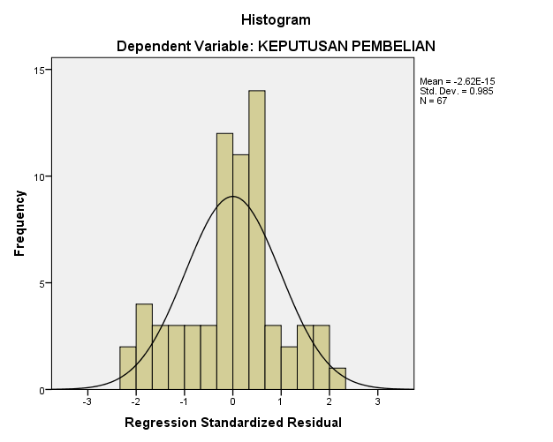

2. Multikolinearitas
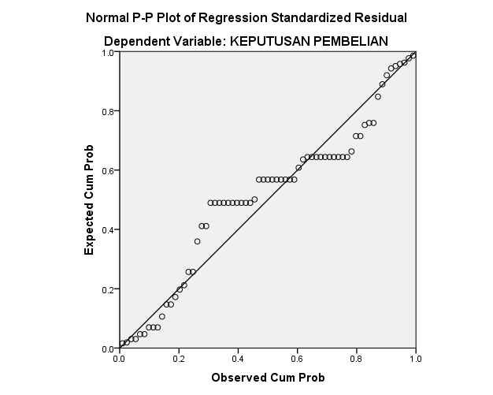

3. Heteroskedastisitas
Coefficientsª
Model |  | Unstandardized Coefficients |  | Standardized Coefficients | t | Sig. | Collinearity Statistics
 |  | B | Std. Error | Beta |  |  | Tolerance | VIF
1 | (Constant) | 61.529 | 5.941 |  | 10.357 | .000
 | CITA RASA | .077 | .080 | .115 | .960 | .341 | .998 | 1.002
 | PROMOSI | .208 | .092 | .271 | -2.262 | .027 | .998 | 1.002
a. Dependent Variable: KEPUTUSAN PEMBELIAN

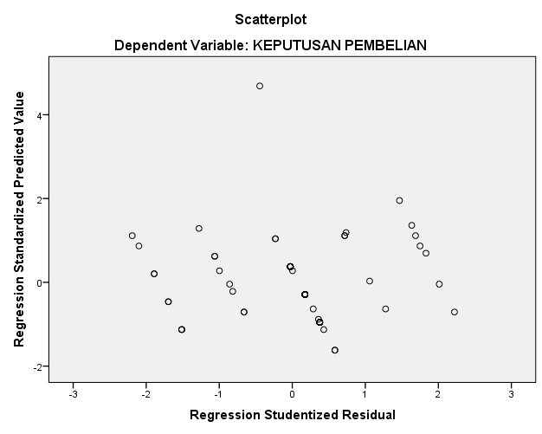
Regresi Linear Berganda
Coefficientsª
Model |  | Unstandardized Coefficients |  | Standardized Coefficients | t | Sig.
 |  | B | Std. Error | Beta
1 | (Constant) | 61.529 | 5.941 |  | 10.357 | .000
 | CITA RASA | .077 | .080 | .115 | .960 | .341
 | PROMOSI | .208 | .092 | .271 | 2.262 | .027
a. Dependent Variable: KEPUTUSAN PEMBELIAN
Uji T
Coefficientsª
Model |  | Unstandardized Coefficients |  | Standardized Coefficients | t | Sig.
 |  | B | Std. Error | Beta
1 | (Constant) | 61.529 | 5.941 |  | 10.357 | .000
 | CITA RASA | .077 | .080 | .115 | .960 | .341
 | PROMOSI | .208 | .092 | .271 | 2.262 | .027
a. Dependent Variable: KEPUTUSAN PEMBELIAN

Uji F
ANOVAª
Model |  | Sum of Squares | Df | Mean Square | F | Sig.
1 | Regression | 6.482 | 2 | 3.241 | 2.922 | .061^{b}
 | Residual | 70.981 | 64 | 1.109
 | Total | 77.463 | 66
a. Dependent Variable: KEPUTUSAN PEMBELIAN
b. Predictors: (Constant), PROMOSI, CITA RASA

Uji Determinasi R²
Model Summary^{b}
Model | R | R Square | Adjusted R Square | Std. Error of the Estimate
1 | .289ª | .584 | .055 | 1.05313
a. Predictors: (Constant), PROMOSI, CITA RASA
b. Dependent Variable: KEPUTUSAN PEMBELIAN

