LAMPIRAN 1
Data Hasil Investasi
Nama perusahaan | Hasil investasi
 | 2017 | 2018 | 2019
Pt. Asuransi jiwa al amin | 411 | 4,023.84 | 4,142.15
Pt. Asuransi jiwa amanahjiwa giri artha | 3,785 | 3,282.83 | 12,525.22
Pt. Asuransi jiwa syariah jasa mitra abadi | 3,643 | 9,033.42 | 8,411.26
Pt. Asuransi syariah keluarga indonesia | 2,955 | 2,198.37 | 2,395.42
Pt. Asuransi jiwa syariah bumiputera | 5 | 4,818.60 | 2,360.09
Pt. Asuransi bri life | 3,727 | 4,502.96 | 7,140.40
Pt. Asuransi central asia | 5,101 | 906.66 | 1,543.54
Pt. Asuransi jiwa adisrana wanaartha | 0 | 2,722.17 | 4,356.89
Pt. Asuransi mega indonesia | 1,846 | 1,350.06 | 2,111.93
Pt. Asuransi jiwa reliance | 0 | 0 | 560.19

Data Pendapatan Premi
Nama perusahaan | Pendapatan Premi
 | 2017 | 2018 | 2019
Pt. Asuransi jiwa al amin | 286,074 | 208,860.60 | 208,860.60
Pt. Asuransi jiwa amanahjiwa giri artha | 30,241 | 22,969.36 | 23,373.92
Pt. Asuransi jiwa syariah jasa mitra abadi | 0 | 32,149.10 | 96,057.78
Pt. Asuransi syariah keluarga indonesia | 18,796 | 29,155.46 | 0
Pt. Asuransi jiwa syariah bumiputera | 40,902 | 116,792.22 | 98,817.51
Pt. Asuransi bri life | 0 | 104,124.27 | 127,397.20
Pt. Asuransi central asia | 15,431 | 11,279.62 | 9,761.06
Pt. Asuransi jiwa adisrana wanaartha | 182 | 41,951.79 | 18,994.80
Pt. Asuransi mega indonesia | 9,452 | 8,657.09 | 9,465.85
Pt. Asuransi jiwa reliance | 0 | 0 | 0

Data Laba Perusahaan
Nama perusahaan | Laba
 | 2017 | 2018 | 2019
Pt. Asuransi jiwa al amin | 4,006 | 4,288.80 | 5,532.73
Pt. Asuransi jiwa amanahjiwa giri artha | 3,503 | -6,976.80 | 7,729.61
Pt. Asuransi jiwa syariah jasa mitra abadi | -1,901 | 552.91 | 1,250.56
Pt. Asuransi syariah keluarga indonesia | 501 | -2,049.45 | 2,645.14
Pt. Asuransi jiwa syariah bumiputera | -25,143 | -7,268.61 | -27,733.00
Pt. Asuransi bri life | 5,266 | 9,644.98 | 16,751.45
Pt. Asuransi central asia | -9,577 | -144.17 | 859.52
Pt. Asuransi jiwa adisrana wanaartha | 4,615 | 13,018.00 | 4,035.29
Pt. Asuransi mega indonesia | 2,576 | 1,116.01 | 1,684.32
Pt. Asuransi jiwa reliance | 2 | 1,745.25 | 1,617.63

LAMPIRAN 2
HASIL UJI SPSS
Descriptive Statistics
 | N | Minimum | Maximum | Mean | Std. Deviation
HASIL INVESTASI | 30 | 0 | 12.525 | 3328.63 | 2921960
PENDAPATAN PREMI | 30 | 0 | 286.074 | 52324.87 | 73199069
LABA | 30 | -27733 | 16.751 | 404.94 | 9038534
Valid N (listwise) | 30

One-Sample Kolmogorov-Smirnov Test
 |  |  | Unstandardized Residual
N |  |  | 30
Normal Parameters^{a,b} | Mean |  | .0000000
 | Std. Deviation |  | 8711.67757037
Most Extreme Differences | Absolute |  | .218
 | Positive |  | .152
 | Negative |  | -.218
Test Statistic |  |  | .218
Asymp. Sig. (2-tailed) |  |  | .001^{c}
Monte Carlo Sig. (2-tailed) | Sig. |  | .095^{d}
 | 99% Confidence Interval | Lower Bound | .088
 |  | Upper Bound | .103
a. Test distribution is Normal.
b. Calculated from data.
c. Lilliefors Significance Correction.
d. Based on 10000 sampled tables with starting seed 624387341.

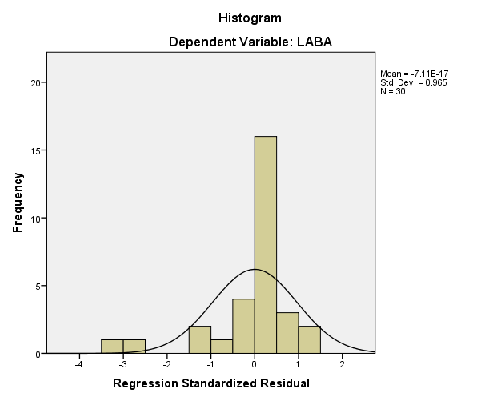
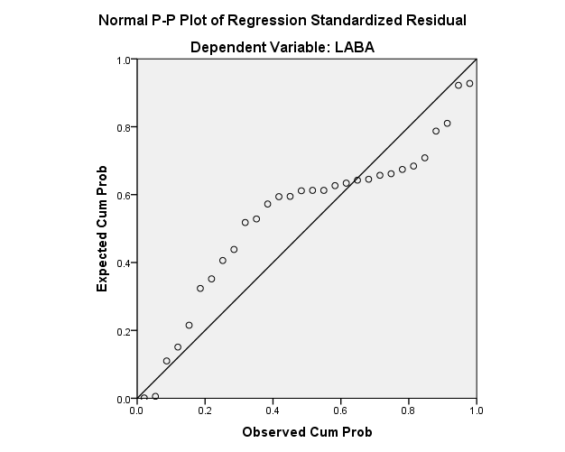

Coefficientsª
Model |  | Collinearity Statistics
 |  | Tolerance | VIF
1 | HASIL INVESTASI | .982 | 1.018
 | PENDAPATAN PREMI | .982 | 1.018
a. Dependent Variable: LABA

Model Summary^{b}
Model | R | R Square | Adjusted R Square | Std. Error of the Estimate | Durbin-Watson
1 | .266ª | .071 | .002 | 9028569 | 1.559
a. Predictors: (Constant), PENDAPATAN PREMI, HASIL INVESTASI
b. Dependent Variable: LABA

Coefficientsª
Model |  | Unstandardized Coefficients |  | Standardized Coefficients | T | Sig.
 |  | B | Std. Error | Beta
1 | (Constant) | -2580800 | 2696987 |  | -.957 | .347
 | HASIL INVESTASI | .777 | .579 | .251 | 1.342 | .191
 | PENDAPATAN PREMI | .008 | .023 | .062 | .331 | .743
a. Dependent Variable: LABA

Coefficientsª
Model |  | Unstandardized Coefficients |  | Standardized Coefficients | T | Sig.
 |  | B | Std. Error | Beta
1 | (Constant) | -2580.800 | 2696.987 |  | -.957 | .347
 | HASIL INVESTASI | .777 | .579 | .251 | 1.342 | .191
 | PENDAPATAN PREMI | .008 | .023 | .062 | .331 | .743
a. Dependent Variable: LABA

ANOVAª
Model |  | Sum of Squares | Df | Mean Square | F | Sig.
1 | Regression | 168251580.164 | 2 | 84125790.082 | 1.032 | .370^{b}
 | Residual | 2200906456.613 | 27 | 81515053.949
 | Total | 2369158036.777 | 29
a. Dependent Variable: LABA
b. Predictors: (Constant), PENDAPATAN PREMI, HASIL INVESTASI

Model Summary^{b}
Model | R | R Square | Adjusted R Square | Std. Error of the Estimate | Durbin-Watson
1 | .266ª | .071 | .002 | 9028.569 | 1.559
a. Predictors: (Constant), PENDAPATAN PREMI, HASIL INVESTASI
b. Dependent Variable: LABA

