Lampiran 1. Data Variabel Penelitian
- Data Audit Tenure (X₁)
No | Kode | Nama Emiten | Tahun
 |  |  | 2017 | 2018 | 2019
1 | ABDA | PT Asuransi Bina Dana, Tbk | 1 | 2 | 2
2 | AHAP | PT Asuransi Harta Aman Pratama, Tbk | 1 | 2 | 2
3 | AMAG | PT. Asuransi Multhi Artha Guna, Tbk | 1 | 2 | 3
4 | ASBI | PT. Asuransi Bintang, Tbk | 2 | 3 | 4
5 | ASDM | PT. Asuransi Dayin Mitra, Tbk | 2 | 3 | 3
6 | ASJT | PT. Asuransi Jaya Tania, Tbk. | 1 | 2 | 3
7 | ASMI | PT. Asuransi Kresna Mitra, Tbk | 1 | 2 | 3
8 | ASRM | PT. Asuransi Ramayana, Tbk | 1 | 2 | 2
9 | PNLF | PT. Panin Insurance, Tbk. | 2 | 3 | 4
10 | LPGI | PT. Lippo General Insurance, Tbk | 1 | 2 | 2
11 | MREI | PT. Maskapai Reasuransi Indonesia, Tbk | 1 | 2 | 3
12 | MTWI | PT. Malacca Trust Wuwungan Insurance, Tbk | 1 | 2 | 3
13 | PNIN | PT. Pannivest, Tbk | 1 | 0 | 0
14 | VINS | PT. Victoria Insurance, Tbk | 1 | 1 | 0
Jumlah |  |  | 17 | 28 | 34
Rataan |  |  | 1.214286 | 2 | 2.428571

Keterangan :
0 : Perusahaan yang Melakukan Audit Tenure Selama 1 Tahun
- : Perusahaan Yang Melakukan Audit Tenure Selama 2 Tahun
- : Perusahaan yang Melakukan Audit Tenure Selama 3 Tahun
- : Perusahaan yang Melakukan Audit Tenure Selama 4 Tahun
- : Perusahaan yang Melakukan Audit Tenure Selama 5 Tahun

- Data Ukuran KAP (X₂)
No | Kode | Nama Emiten | Tahun
 |  |  | 2017 | 2018 | 2019
1 | ABDA | PT Asuransi Bina Dana, Tbk | 0 | 0 | 0
2 | AHAP | PT Asuransi Harta Aman Pratama, Tbk | 1 | 1 | 1
3 | AMAG | PT. Asuransi Multhi Artha Guna, Tbk | 0 | 0 | 0
4 | ASBI | PT. Asuransi Bintang, Tbk | 0 | 0 | 0
5 | ASDM | PT. Asuransi Dayin Mitra, Tbk | 1 | 1 | 1
6 | ASJT | PT. Asuransi Jaya Tania, Tbk. | 1 | 1 | 1
7 | ASMI | PT. Asuransi Kresna Mitra, Tbk | 0 | 0 | 0
8 | ASRM | PT. Asuransi Ramayana, Tbk | 1 | 1 | 1
9 | PNLF | PT. Panin Insurance, Tbk. | 1 | 1 | 1
10 | LPGI | PT. Lippo General Insurance, Tbk | 0 | 0 | 1
11 | MREI | PT. Maskapai Reasuransi Indonesia, Tbk | 0 | 0 | 0
12 | MTWI | PT. Malacca Trust Wuwungan Insurance, Tbk | 0 | 0 | 1
13 | PNIN | PT. Pannivest, Tbk | 0 | 0 | 1
14 | VINS | PT. Victoria Insurance, Tbk | 0 | 0 | 0
Jumlah |  |  | 5 | 5 | 8
Rataan |  |  | 0.357143 | 0.357143 | 0.571429

Keterangan :
- : Perusahaan di audit oleh KAP the big four
- : Perusahaan di audit oleh KAP non big four

- Kualitas Audit (Y)
No | Kode | Nama Emiten | Tahun
 |  |  | 2017 | 2018 | 2019
1 | ABDA | PT Asuransi Bina Dana, Tbk | 1 | 0 | 0
2 | AHAP | PT Asuransi Harta Aman Pratama, Tbk | 1 | 0 | 0
3 | AMAG | PT. Asuransi Multhi Artha Guna, Tbk | 1 | 0 | 0
4 | ASBI | PT. Asuransi Bintang, Tbk | 1 | 0 | 1
5 | ASDM | PT. Asuransi Dayin Mitra, Tbk | 1 | 0 | 1
6 | ASJT | PT. Asuransi Jaya Tania, Tbk. | 0 | 1 | 1
7 | ASMI | PT. Asuransi Kresna Mitra, Tbk | 1 | 1 | 1
8 | ASRM | PT. Asuransi Ramayana, Tbk | 1 | 0 | 0
9 | PNLF | PT. Panin Insurance, Tbk. | 0 | 0 | 0
10 | LPGI | PT. Lippo General Insurance, Tbk | 1 | 1 | 1
11 | MREI | PT. Maskapai Reasuransi Indonesia, Tbk | 0 | 1 | 1
12 | MTWI | PT. Malacca Trust Wuwungan Insurance, Tbk | 1 | 1 | 1
13 | PNIN | PT. Pannivest, Tbk | 1 | 0 | 0
14 | VINS | PT. Victoria Insurance, Tbk | 1 | 1 | 0
Jumlah |  |  | 11 | 6 | 7
Rataan |  |  | 0.785714 | 0.428571 | 0.5

Keterangan :
- : Perusahaan yang tidak menerima opini audit going concern
- : Perusahaan yang menerima opini audit going concern

Lampiran 2. Hasil Output SPSS
Lampiran

LOGISTIC REGRESSION VARIABLES Y
/METHOD=ENTER X1 X2
/CLASSPLOT
/PRINT=GOODFIT CORR ITER(1)
/CRITERIA=PIN(0.05) POUT(0.10) ITERATE(20) CUT(0.5).

Logistic Regression

Notes
Output Created |  | 13-JUL-2021 13:26:48
Comments
Input | Active Dataset | DataSet0
 | Filter | <none>
 | Weight | <none>
 | Split File | <none>
 | N of Rows in Working Data File | 42
Missing Value Handling | Definition of Missing | User-defined missing values are treated as missing
Syntax |  | LOGISTIC REGRESSION VARIABLES Y  /METHOD=ENTER X1 X2  /CLASSPLOT  /PRINT=GOODFIT CORR ITER(1)  /CRITERIA=PIN(0.05) POUT(0.10) ITERATE(20) CUT(0.5).
Resources | Processor Time | 00:00:00.02
 | Elapsed Time | 00:00:00.03

[DataSet0]

Case Processing Summary
Unweighted Casesª |  | N | Percent
Selected Cases | Included in Analysis | 42 | 100.0
 | Missing Cases | 0 | .0
 | Total | 42 | 100.0
Unselected Cases |  | 0 | .0
Total |  | 42 | 100.0
a. If weight is in effect, see classification table for the total number of cases.

Dependent Variable Encoding
Original Value | Internal Value
Memiliki Kualitas Audit Yang Kurang Baik | 0
Memiliki Kualitas Audit Yang Baik | 1

Block 0: Beginning Block

Iteration History^{a,b,c}
Iteration |  | -2 Log likelihood | Coefficients
 |  |  | Constant
Step 0 | 1 | 56.691 | -.381
 | 2 | 56.691 | -.386
 | 3 | 56.691 | -.386
a. Constant is included in the model.
b. Initial -2 Log Likelihood: 56.691
c. Estimation terminated at iteration number 3 because parameter estimates changed by less than .001.

Classification Table^{a,b}
 | Observed |  | Predicted
 |  |  | Kualitas Audit |  | Percentage Correct
 |  |  | Memiliki Kualitas Audit Yang Kurang Baik | Memiliki Kualitas Audit Yang Baik
Step 0 | Kualitas Audit | Memiliki Kualitas Audit Yang Kurang Baik | 25 | 0 | 100.0
 |  | Memiliki Kualitas Audit Yang Baik | 17 | 0 | .0
 | Overall Percentage |  |  |  | 59.5
a. Constant is included in the model.
b. The cut value is .500

Variables in the Equation
 |  | B | S.E. | Wald | df | Sig. | Exp(B)
Step 0 | Constant | -.386 | .314 | 1.505 | 1 | .220 | .680

Variables not in the Equation
 |  |  | Score | df | Sig.
Step 0 | Variables | X1 | 2.421 | 1 | .120
 |  | X2 | 1.549 | 1 | .213
 | Overall Statistics |  | 5.423 | 2 | .066

Block 1: Method = Enter

Iteration History^{a,b,c,d}
Iteration |  | -2 Log likelihood | Coefficients
 |  |  | Constant | X1 | X2
Step 1 | 1 | 51.095 | -1.035 | -1.314 | .880
 | 2 | 50.983 | -1.237 | -1.488 | 1.029
 | 3 | 50.983 | -1.247 | -1.497 | 1.036
 | 4 | 50.983 | -1.247 | -1.497 | 1.036
a. Method: Enter
b. Constant is included in the model.
c. Initial -2 Log Likelihood: 56.691
d. Estimation terminated at iteration number 4 because parameter estimates changed by less than .001.

Omnibus Tests of Model Coefficients
 |  | Chi-square | df | Sig.
Step 1 | Step | 5.709 | 2 | .038
 | Block | 5.709 | 2 | .038
 | Model | 5.709 | 2 | .038

Model Summary
Step | -2 Log likelihood | Cox & Snell R Square | Nagelkerke R Square
1 | 50.983ª | .326 | .457
a. Estimation terminated at iteration number 4 because parameter estimates changed by less than .001.

Hosmer and Lemeshow Test
Step | Chi-square | df | Sig.
1 | 8.278 | 3 | .089

Contingency Table for Hosmer and Lemeshow Test
 |  | Kualitas Audit = Memiliki Kualitas Audit Yang Kurang Baik |  | Kualitas Audit = Memiliki Kualitas Audit Yang Baik |  | Total
 |  | Observed | Expected | Observed | Expected
Step 1 | 1 | 6 | 6.772 | 2 | 1.228 | 8
 | 2 | 10 | 10.589 | 6 | 5.411 | 16
 | 3 | 6 | 3.867 | 1 | 3.133 | 7
 | 4 | 3 | 1.639 | 1 | 2.361 | 4
 | 5 | 0 | 2.133 | 7 | 4.867 | 7

Classification Tableª
 | Observed |  | Predicted
 |  |  | Kualitas Audit |  | Percentage Correct
 |  |  | Memiliki Kualitas Audit Yang Kurang Baik | Memiliki Kualitas Audit Yang Baik
Step 1 | Kualitas Audit | Memiliki Kualitas Audit Yang Kurang Baik | 22 | 3 | 88.0
 |  | Memiliki Kualitas Audit Yang Baik | 9 | 8 | 47.1
 | Overall Percentage |  |  |  | 71.4
a. The cut value is .500

Variables in the Equation
 |  | B | S.E. | Wald | df | Sig. | Exp(B)
Step 1ª | X1 | -1.497 | .767 | 3.805 | 1 | .051 | .224
 | X2 | 1.036 | .597 | 3.010 | 1 | .083 | 2.818
 | Constant | 1.247 | 1.036 | 1.449 | 1 | .229 | .287
a. Variable(s) entered on step 1: X1, X2.

Correlation Matrix
 |  | Constant | X1 | X2
Step 1 | Constant | 1.000 | -.047 | -.843
 | X1 | -.047 | 1.000 | -.409
 | X2 | -.843 | -.409 | 1.000

Step number: 1

Observed Groups and Predicted Probabilities

16 + 1 +
I 1 I
I 1 I
F I 1 I
R 12 + 1 +
E I 1 I
Q I 0 I
U I 0 I
E 8 + 1 0 +
N I 1 0 1 1 I
C I 0 0 0 1 I
Y I 0 0 0 1 I
4 + 0 0 0 1 1 +
I 0 0 0 0 1 I
I 0 0 0 0 1 I
I 0 0 0 0 1 I
Predicted ---------+---------+---------+---------+---------+---------+---------+---------+---------+----------
Prob: 0 .1 .2 .3 .4 .5 .6 .7 .8 .9 1
Group: 0000000000000000000000000000000000000000000000000011111111111111111111111111111111111111111111111111

Predicted Probability is of Membership for Memiliki Kualitas Audit Yang Baik
The Cut Value is .50
Symbols: 0 - Memiliki Kualitas Audit Yang Kurang Baik
1 - Memiliki Kualitas Audit Yang Baik
Each Symbol Represents 1 Case.

Residuals Statisticsª
 | Minimum | Maximum | Mean | Std. Deviation | N
Predicted Value | .31 | 1.10 | .67 | .192 | 42
Residual | -.599 | .692 | .000 | .437 | 42
Std. Predicted Value | -1.865 | 2.261 | .000 | 1.000 | 42
Std. Residual | -1.339 | 1.546 | .000 | .975 | 42
a. Dependent Variable: Kualitas Audit

Charts
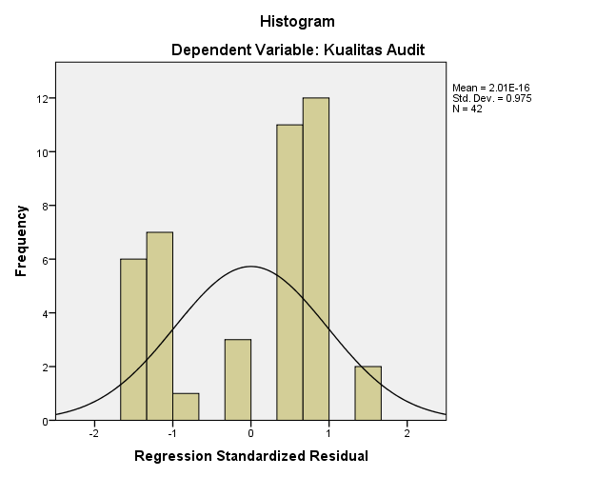

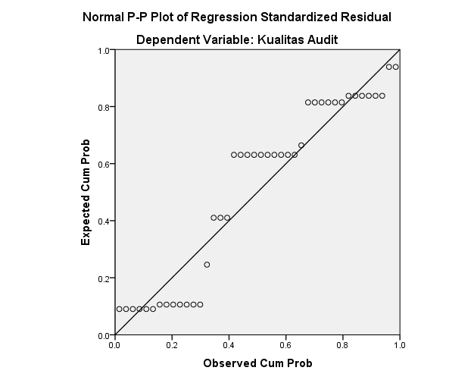

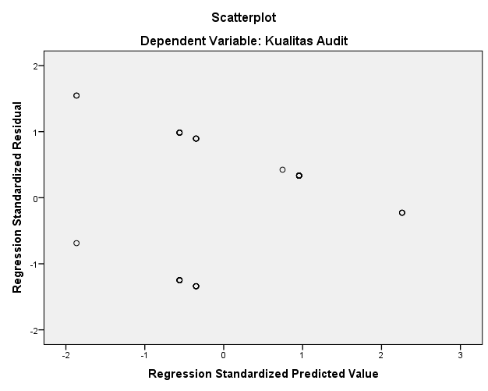

Descriptives

Notes
Output Created |  | 06-JUL-2021 20:17:04
Comments
Input | Active Dataset | DataSet1
 | Filter | <none>
 | Weight | <none>
 | Split File | <none>
 | N of Rows in Working Data File | 42
Missing Value Handling | Definition of Missing | User defined missing values are treated as missing.
 | Cases Used | All non-missing data are used.
Syntax |  | DESCRIPTIVES VARIABLES=Y X1 X2  /STATISTICS=MEAN STDDEV MIN MAX.
Resources | Processor Time | 00:00:00.00
 | Elapsed Time | 00:00:00.01

[DataSet1]

Descriptive Statistics
 | N | Minimum | Maximum | Mean | Std. Deviation
Kualitas Audit | 42 | 0 | 1 | .67 | .477
Audit Tenure | 42 | 1 | 3 | 1.74 | .627
Ukuran KAP | 42 | 0 | 1 | .40 | .497
Valid N (listwise) | 42

NPAR TESTS
/K-S(NORMAL)=RES_1
/MISSING ANALYSIS.

NPar Tests

Notes
Output Created |  | 06-JUL-2021 20:17:20
Comments
Input | Active Dataset | DataSet1
 | Filter | <none>
 | Weight | <none>
 | Split File | <none>
 | N of Rows in Working Data File | 42
Missing Value Handling | Definition of Missing | User-defined missing values are treated as missing.
 | Cases Used | Statistics for each test are based on all cases with valid data for the variable(s) used in that test.
Syntax |  | NPAR TESTS  /K-S(NORMAL)=RES_1  /MISSING ANALYSIS.
Resources | Processor Time | 00:00:00.02
 | Elapsed Time | 00:00:00.06
 | Number of Cases Allowedª | 196608
a. Based on availability of workspace memory.

[DataSet1]

One-Sample Kolmogorov-Smirnov Test
 |  | Unstandardized Residual
N |  | 42
Normal Parameters^{a,b} | Mean | 0E-7
 | Std. Deviation | .43662107
Most Extreme Differences | Absolute | .229
 | Positive | .209
 | Negative | -.229
Kolmogorov-Smirnov Z |  | 1.486
Asymp. Sig. (2-tailed) |  | .724
a. Test distribution is Normal.
b. Calculated from data.

